**Content Management System using PHP & MySQL Database**

**  
 Final Report**

Submitted To:  
Dr. Gaurav Aggarwal  
 (H.O.D) Submitted By:  
 Namit  
 B.Tech(C.S.E)  
 Sem: 8th  
 020114004

Copyright © 2018 Namit Dhupar. The author grants Jagannath University the nonexclusive right to make this work available for noncommercial, educational purposes, provided that this copyright statement appears on the reproduced materials and notice is given that the copying is by permission of the author. To disseminate otherwise or to republish requires written permission from the author.

**ABSTRACT OF THE THESIS**

Building a Web Content Management System

By

Namit Dhupar

B.Tech, in Computer Science Jagannath University, 2018

This thesis investigates different existing open-source Web Content Management Systems (WCMS) and their features. The main objective of WCMS is to allow non-technical users to easily update and manage a website’s content. But WCMS products available on the market today have integrated many other complex functionalities, which makes the user interface difficult to understand and use. All WCMS require some amount of training on installation and where to start. After integration users need to read the manual or take lessons to use other available advanced features. The research question explored here is whether to implement a WCMS from existing options compared with the feasibility of building a new one from scratch. This paper discusses the considerations of developing a new WCMS.

**ACKNOWLEDGEMENTS**

I would sincerely like to thank my project advisor and thesis chair Prof. Gaurav Aggarwal for his continuous guidance and motivation during my thesis research.

**CHAPTER 1**

**INTRODUCTION**

Content management (CM) is the set of processes and technologies that support the collection, managing, and publishing of information in any form or medium. Content may take the form of text (such as documents), multimedia files (such as audio or video files), or any other file type that follows a content lifecycle requiring management. Content management is an inherently collaborative process. It often consists of the following basic roles and responsibilities:

0

(i) Creator: responsible for creating and editing content.

(ii) Editor: responsible for modifying the style of delivery, including translation

(iii) Publisher: responsible for releasing the content for use.

(iv) Administrator: responsible for managing access permissions to folders/ pages .

(v) Comsumer, viewer, or guest: the person who reads or otherwise takes in content

**1.1 WHAT IS A CONTENT MANAGEMENT SYSTEM**

**(CMS)?**

A content management system (CMS) is a computer system or an application that allows publishing, editing, or modification of content, as well as site maintenance, from a central page . The content on the World Wide Web consists of HTML, XML, and other documents and media files. This content can be published manually by editing and organizing files on a file system exposed to the web through a web server, requiring much technical expertise and tedious work. Content management systems store the actual content which can be text or images in a database. The system then automatically pulls the content out and shows it on appropriate pages based on the rules. Content management systems were created to help people publish documents and media with less technical intervention and in a more consistent and automated fashion. Anything from a document management system, to a

media asset management system, to a portal, to a blog system could be considered a Content Management System .

Content management system speeds up the content updating process and makes it easy for a non-technical user. This helps in keeping the content up-to-date and timely. They are frequently used for editing, controlling, versioning and publishing specific documentation. They are used for different types of applications to manage its content. Below are some of the CMS applications.

Blogs: comments on a particular topic;

News: reading newspapers online instead of reading the hard/physical copy;

Wikis: these are open to public editing.

The core features of Content Management Systems vary widely from system to

system; many simpler systems provide only a handful of features, while others, especially enterprise systems, are much more complex and powerful.

Allow for a large number of people to share and contribute to stored data

**(A)**

Control access to data based on user role (i.e., define information users or user groups can view, edit, publish, etc.)

**(B)**

Facilitate storage and retrieval ;

Simplify report writing;

Define data as almost anything: documents, movies, texts, pictures, phone numbers, articles etc.

**1.2 PROJECT DEFINITION AND PURPOSE**

In this thesis, I have built a Simple CMS which is a web content management system that can be used to dynamically manage the content of a simple static HTML website. For.eg. the news section of the Computer Science Department needs to be updated very often and since it is static HTML page, a technical person having knowledge of HTML and CSS is required to update even a small portion of the section.

most common CMS functions appropriate for small and simple websites, so that a novice user can manage the website content. A user having less coding knowledge can easily add, edit and format the website’s content using the rich text editor integrated in the Simple CMS engine without having to deal with the HTML and CSS code.

**CHAPTER 2**

**BACKGROUND**

**2.1 A SHORT HISTORY OF CMS DEVELOPMENT**

Claims about who wrote the first CMS are varied, and include Roxen (1994) and Blitzen (mid-1990s), Ingeniux (1999), and Vignette. The main features were a very structured development environment and one had to use tags and templates because there was no WYSIWYG (What You See Is What You Get) editor. If one could not use HTML, they probably were not going to edit their site. Most of those websites were written by web design agencies rather than by software companies, and every agency had their own web designers who could write HTML code.

The second stage of CMS development was led by software houses who took over the functionality and started to build today’s CMS. Key features which were slowly built in included WYSIWYG text editing, search, and the addition of features like survey tools and podcasts. An early stage leader RedDot, and others, led the growth of specialists such as DotNetNuke and Mambo (which later changed to Joomla and DotNetNuke), which are still used today. CMS became feature-rich and web agencies needed both the technical skills, as well as designers, to adapt each client site into the CMS frameworks

**2.2 WHO NEEDS A CONTENT MANAGEMENT SYSTEM?**

Organizations need a content management system if they:

**(A)** Use the same content over and over again in one publication (e.g., a warning in an instruction manual may be used several times within that manual).

**(B)** Publish the content to more than one media channel (e.g., the content in a printed instruction manual that ships with the product may also be used in the online help information).

**(C)** Publish the content in multiple languages.

**(D)** The types of publications that these organizations include:

**a.)** Technical documentation (parts catalogs, software), Reference

**b.)** Testing and training materials (e-learning programs, testing booklets)

**c.)** Marketing and educational materials (packaging, promotional flyers and ads, brochures) .

**2.3 TYPES OF CONTENT MANAGEMENT SYSTEMS**

CMS come in all shapes and sizes, and can manage anything a team of individuals is working on. From managing simple static website content, to allowing collaborative documentation across the Internet (wiki), CMSs perform many functions. CMS packages can generally be classified into two categories: Enterprise CMS and Web CMS.

**2.3.1 Enterprise CMS**

Enterprise Content Management (ECM) is a formalized means of organizing and storing documents, and other content, that relate to the organization's processes. These high-powered software packages are usually comprehensive solutions, delivering effective content management for use on an enterprise, or corporate level .

They are designed to help a corporation become more efficient and cost-effective, and increase accuracy and functionality. It also helps decrease human error and customer response times. They can integrate corporate functions such as shipping and delivery systems, invoicing, employee and human resource issues, customer relations, and document management and sales systems. Enterprise CMS brings data management down to the user’s level, so many users can add their individual piece of information to a very large integrated system data. Software companies deploying these complex systems offer highly customized company-wide solutions, which means the software usually comes with a relatively high price tag.

This type of CMS is generally used by large e-Commerce organizations. E-commerce websites are those that have a shopping cart designed to sell items online. The examples of such CMS used for e-Commerce websites are OSCommerce, Magneto etc.

**2.3.2 Web CMS**

Today, we are all used to the idea that we can create our own documents and publish it on the web. But if we go back fifteen or more years, the only way one could create a website was by understanding 'HTML’. Products like Dreamweaver and Frontpage were not around; this meant that if one wanted to build a website then he/she needed someone with technical skills to write it. Also once they had written it, one still needed someone with technical skills to change it, as changes involved reading HTML code to determine where to add content .

A Web Content Management System (WCMS) is a software system that provides website authoring, collaboration, and administration tools designed to allow users to create and manage website content with ease. A presentation layer displays the content to the website visitors based on the set of templates . WCMS were developed to resolve the issue of having highly experienced technical staff adding low-level content to a website. WCMS is a web application used to create, manage, store and deploy content on web pages. It is mainly a website maintenance tool that allows non-technical users to make changes to the website, and therefore the website’s authoring and administrating tools. A user with little knowledge of programming languages can easily create and maintain the site’s content. Web content types can include text, graphics and photos, video or audio, and an application code that renders other content or interacts with the visitor. Web content may be created, organized, and managed in an unlimited number of ways. Therefore a wide variety of WCMS systems have been built to handle many different situations.

**CHAPTER 3**

**TOOLS**

Several technological tools were used in this project; each is summarized in the sections that follow.

**3.1 HTML**

HTML stands for Hyper Text Markup Language. A markup language is a language that annotates text in a way that is syntactically distinguishable so that the computer can manipulate it. It is a set of markup tags used to describe web pages. The tags are what separate normal text from HTML code. They are the words between the <angle-brackets>. Different tags will perform different functions, like rendering images or tables. It is a combination of words and symbols which give instructions on how the document will be presented. The tags themselves don’t appear when you view your page through a browser, but their effects do.

Markup is what HTML tags do to the text inside them. They mark it as a certain type of text (italicized text, for example) . HTML documents contain HTML tags and plain text. The content on a HTML page will be static. In order to change the content, the editor needs to have some knowledge about HTML and change the content accordingly.

**3.2 CSS**

CSS stands for Cascading Style Sheets. It is used to control the style and layout of multiple web pages all at once. Styles define how to display HTML elements. CSS overrides the browser’s default settings for interpreting how tags should be displayed, letting you use any HTML element indicated by an opening and closing tag to apply style attributes defined either locally or in a stylesheet.

External Style Sheets can save a lot of work. They are stored in CSS files. Stylesheets contain rules, composed of selectors and declarations that define how styles will be applied. The selector (a redefined HTML element, class name, or ID name) is the link

**3.3 JAVASCRIPT**

JavaScript is a client side scripting language designed to add interactivity to HTML pages. A scripting language is a lightweight programming language. It is usually embedded directly into HTML pages. It is an interpreted language which allows the scripts to execute without preliminary compilation.

JavaScript can react to events. A JavaScript can be set to execute when something happens, like when a page has finished loading or when a user clicks on an HTML element. JavaScript can read and write HTML elements and can also change it’s content and properties. A JavaScript can be used to validate form data before it is submitted to a server. This saves the server from extra processing. A JavaScript can be used to detect the visitor's browser, and depending on the browser, load another page specifically designed for that browser. Finally, JavaScript can be used to create cookies and to store and retrieve information on the visitor's computer .

**3.4 PHP**

PHP (Hypertext Preprocessor) is a widely-used open source server-side scripting language for web development and can be embedded into HTML. PHP pages contain HTML with embedded code . PHP offers several advantages:

PHP runs on different platforms (Windows, Linux, Unix, etc.).

**(A)**

PHP is compatible with almost all servers used today (Apache, IIS, etc.). PHP is free to download from the official PHP resource: www.php.net. PHP is easy to learn and runs efficiently on the server side .

**(B)**

What distinguishes PHP from something like client-side JavaScript is that the code is

executed on the server, generating HTML, which is then sent to the client. The client receives the results of running that script, but does not know what the underlying code was .

**3.5 MYSQL**

MySQL is a database server is ideal for both small and large applications. It supports standard SQL and compiles on a number of platforms. It is free to download and use .

**CHAPTER 4**

**INSTALLATION & GETTING STARTED**

**4.1 Software Used**

In the following Thesis Demonstration, the Tools and Versions used are:

**i.)** PHP 7.0.30 (Zend Engine)  
**ii.)** MySQL Database 8.0.11  
**iii.)** PHPmyAdmin 4.7.9  
**iv.)** WAMP X64  
**v.)** Apache HTTP Server

**1.) PHPmyAdmin**: phpMyAdmin is a free software tool written in [PHP](https://php.net/), intended to handle the administration of  [MySQL](https://www.mysql.com/) over the Web. phpMyAdmin supports a wide range of operations on MySQL and MariaDB. Frequently used operations (managing databases, tables, columns, relations, indexes, users, permissions, etc) can be performed via the user interface, while you still have the ability to directly execute any SQL statement.

**2.) WAMP**: WampServer is a Windows web development environment. It allows you to create web applications with Apache2, PHP and a MySQL database. Alongside, PhpMyAdmin allows you to manage easily your

**3.) Apache HTTP Server**: Apache is the most widely used web server software. Developed and maintained by Apache Software Foundation, Apache is an open source software available for free. It runs on 67% of all webservers in the world. It is fast, reliable, and secure. It can be highly customized to meet the needs of many different environments by using extensions and modules.

4.2) **Turning on Some important features:**

in wamp, go to PHP tools => phpInfo() -> Set the following:  
a.) display_errors = **ON**   
  
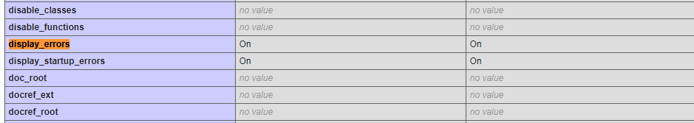  
b.) output_buffer = **4096 Bytes**

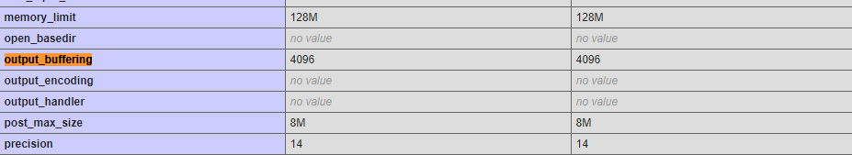

**4.3.) Designing the Frontend of the Website:**

**Get a bootstrap template for:**

*a.) Content Management System*: Constructed using HTML, CSS, Bootstrap

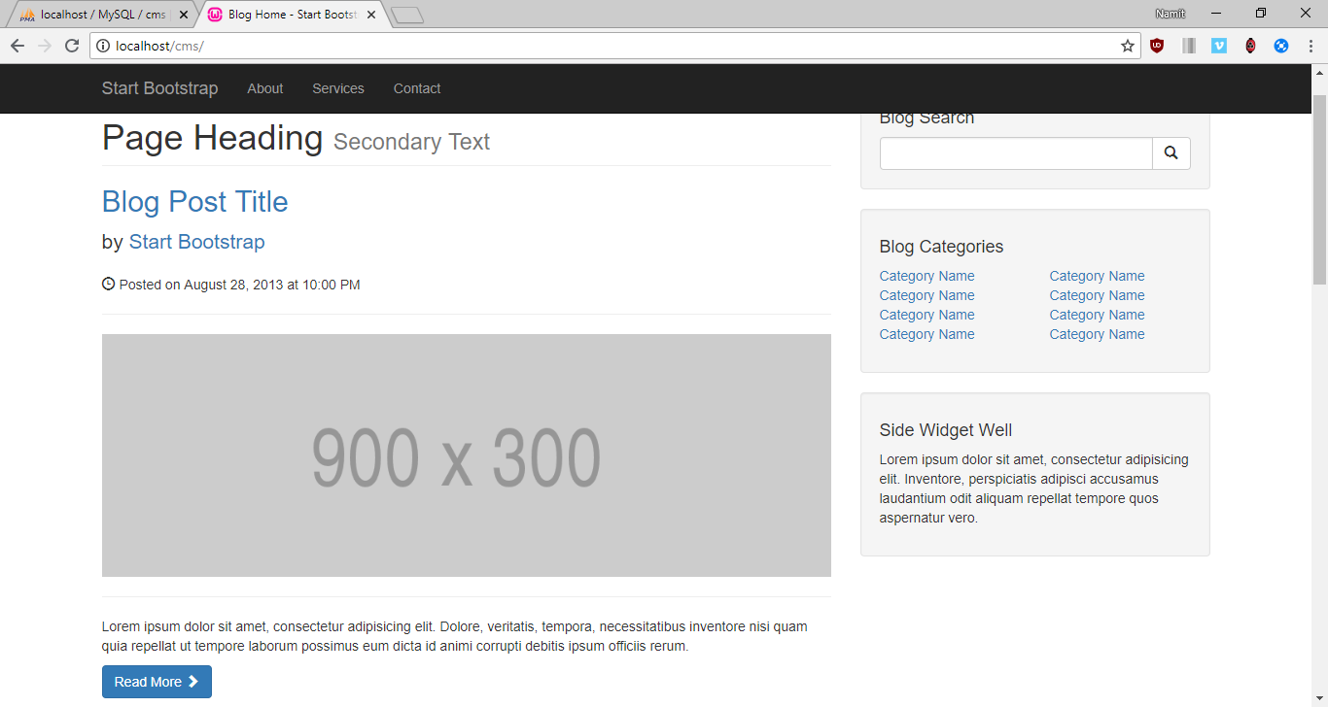

*b.)As well as Admin:*

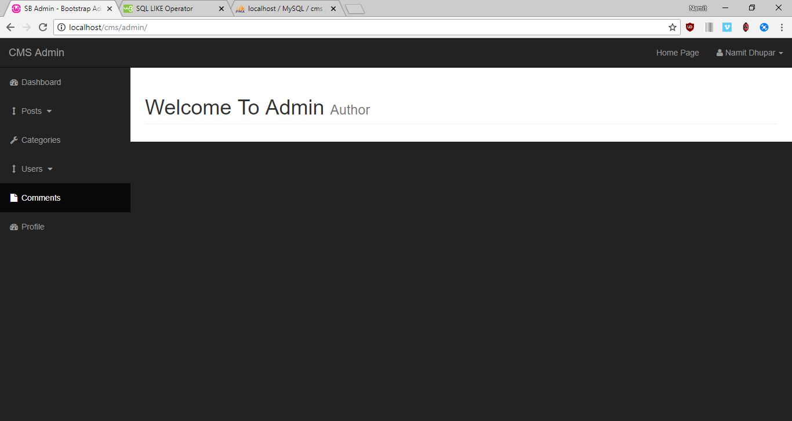  
**4.4) Setting up the Database( Categories & Post Table ):**

**Build a database in localhost/phpmyadmin called CMS, and tables such as**:  
 a.) *Courier* : having 2 columns   
 i.) cat_id(Int) = Primary Key, autoIncrement  
 ii.) cat_title(Varchar) = length : 255

The cat_title will have the following structure, such that we pull the information from our mySQL database and then we display it withing the TOP NAVBAR with PHP syntax  
  
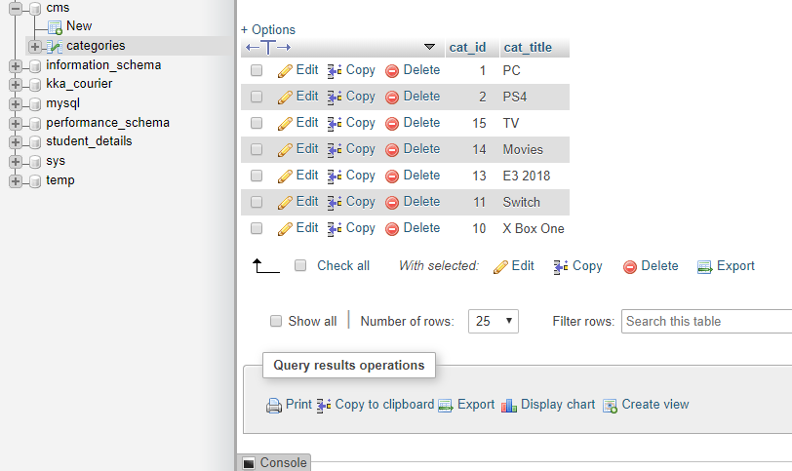

Such that, the TOP NAVBAR looks like the following: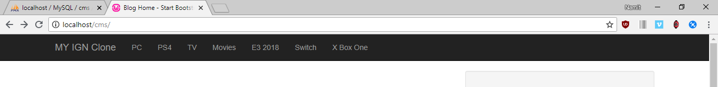

Now To Enable the Main Posts to be made Dynamically in the website, we create another table called *posts*

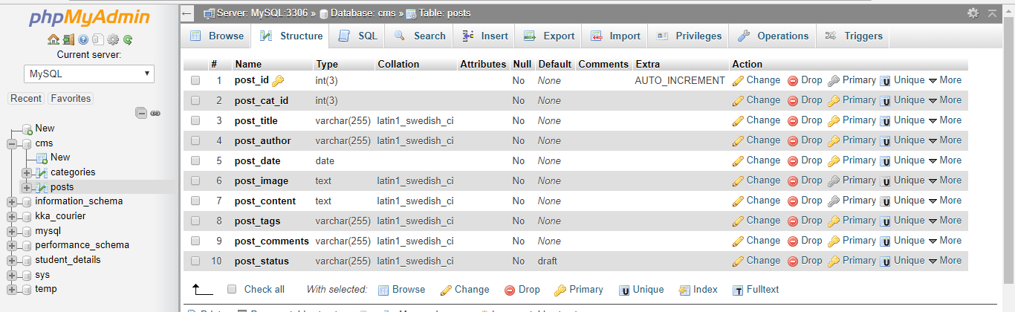

After entering information in the Posts inside the database, we fetch the posts columns from the Database into our website, which now looks like this:

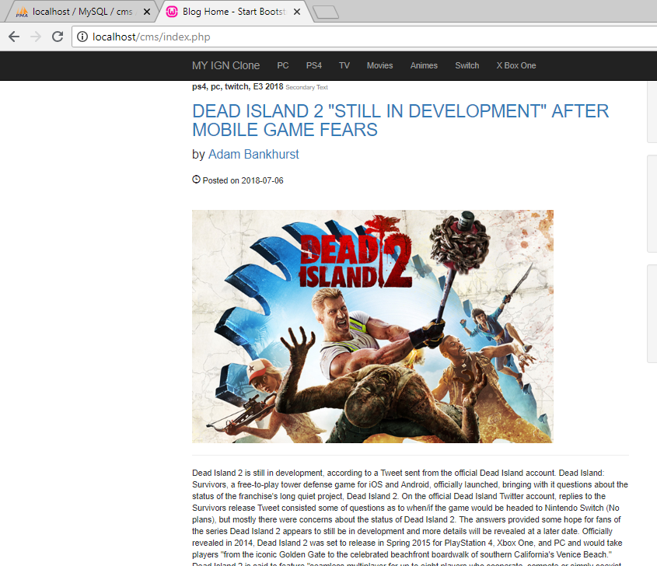

4.5) **Making Search Engine:**

In order to construct a search engine, we need to create an input form with the “POST” type HTTP request method, along with that, we shall name the buttons, input spaces accordingly.

*The Search form:* 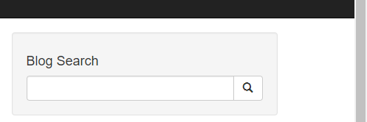

The Search Engine works as following: Such that whenever we pass an input inside the above text field, we try to match or compare the entered keys with the information already inside our database, which would in turn find the required string and present that in the webpage.

So for that, an SQL Query is used which will be: **“ SELECT * FROM posts WHERE post_tags LIKE ‘%$search%’ ”;**

The contents of post_tags column inside the database looks as follows:

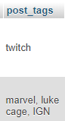

And if there are no such rows obtained, then with the help of an SQL function ie “ **mysqli_num_row()** “,   
we can throw a Result not found error message: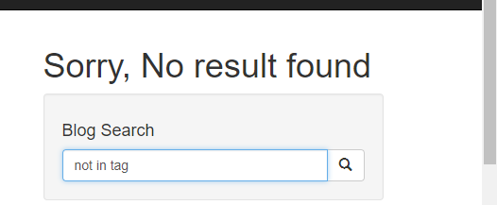

So, the functionality of the search engine should be that it must display just one individual Post, which contains the ‘Searched’ keyword in it’s table’s column, such that: “Observe the contents of the Search box and the highlighted text, which thereby concludes that our Search Engine works.

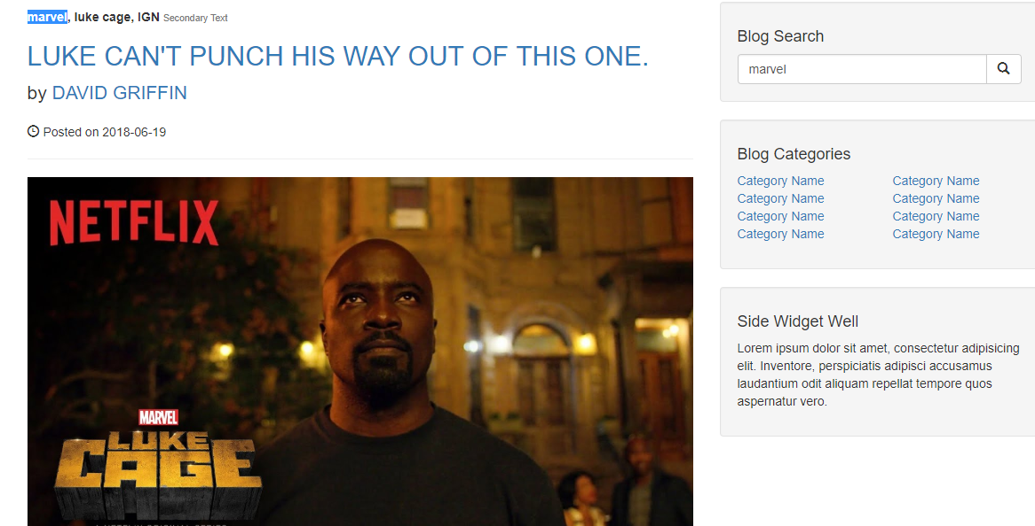

4.6 **Sidebar UI**

The Sidebar UI is the component of the webpage, which displays the “BLOG CATEGORIES” section,

And in order to make this particular section relevant, we fetch the category title from the database and append them onto the Sidebar section, with the help of the following MySQL query= “SELECLT * FROM categories” where categories is the table name, such that it looks like follows after a successful query execution:

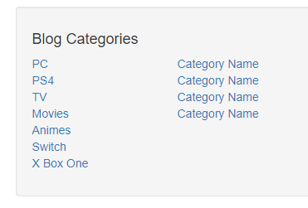

We can even reduce the number of category titles to be displayed in the sidebar with the help of LIMIT keyword within the mySQL query, so now the sidebar looks like:

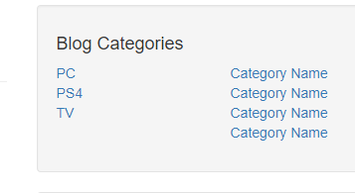

**CHAPTER 5**

**CREATING CATEGORIES**

**5.1 Admin Page:**

Initially, our admin page looks as follows



**5.2 Adding Category**:  
 Within The admin page, we have an ADD Category, where we have a text box input in which we enter some characters and send them into the catagories table of the Database: The Page looks as Follows, where I have shown the contents of the database as Bootstrap table, and My aim is to append more data within the table just be entering it inside the text box.

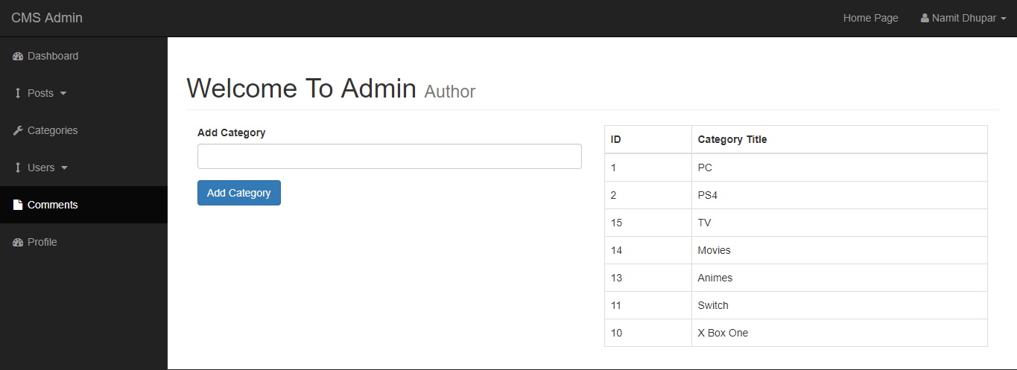

And this is achieved by the following **MySQL query : “INSERT INTO categories(cat_title) VALUE (‘{$cat_title}’)”;**

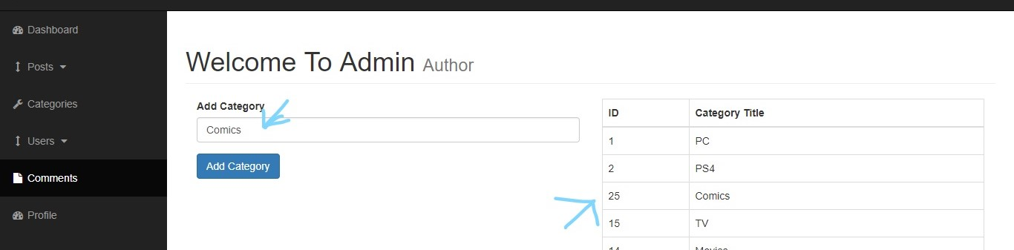

So now we add an additional column called ‘Comics’.

**5.3** **Deleting a Category**: We make another column in the following Table, called Delete;

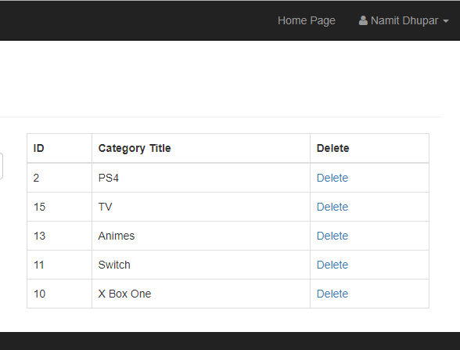

And in order for Delete to come into action, we use the **following MySQL Query “DELETE FROM categories WHERE cat_id = {$cat_id} “;**

And for the deletion to take effect in the php page, we redirect to that same page via a **PHP function of header(“Location: categories.php”).**

For Example, If we want to Delete Switch from the table, we simply click on the ‘delete’ link in same column, Hence we see that “Switch is now no longer in Database.

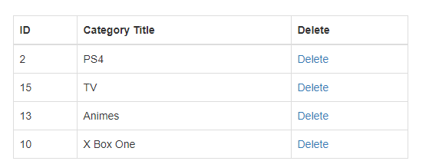

**5.4 Updating a category:** For that we make a separate form which will update the category of the entered ID/Title

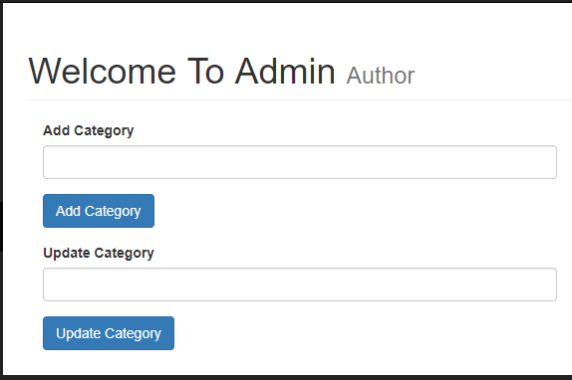

And Along with that we make another column in the table called ‘Edit’, and it’s purpose will be that when the admin user clicks on the ‘Edit’ link, the category title belonging to that category id will get added to the Input Text region and hence we will be able to edit to it further and make Update it’s value within the database.

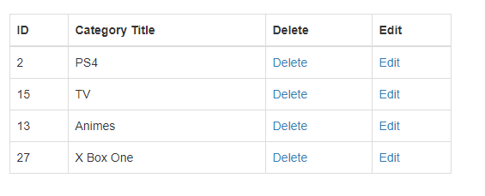  
The MySQL Query that enables us to do so is: “**SELECT * FROM categories WHERE cat_id = {$cat_id}”;**For example, If we want to edit the PS4 title, then simply, click on edit and we see the following:

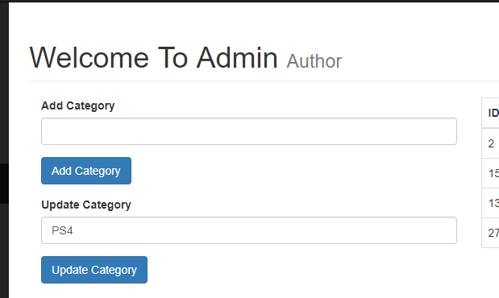

To Update the title(PS4 in this case), we use the following MySQL Query: **“UPDATE categories SET cat_title = ‘{$updated_title}’ WHERE cat_id = $cat_id “;**

Hence, we obtain the updated result successfully as:

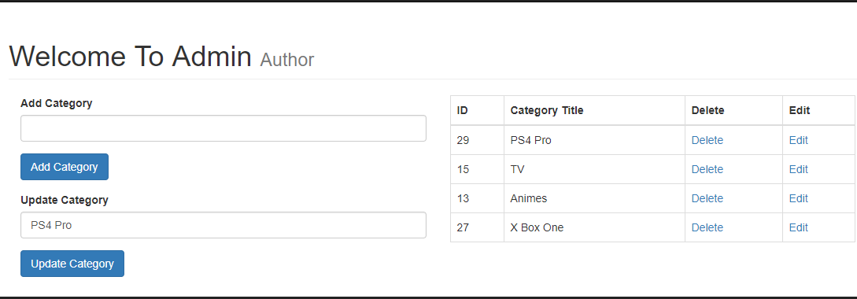

**CHAPTER 6**

**CREATING POSTS**

**6.1**  **Adding A Post :**

Inside the Admin, We have another Side bar entity called **Post,** which is a dropdown, that gives us an option for Either Adding or Viewing post.

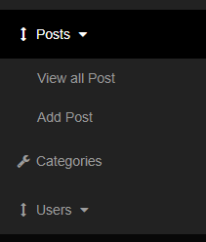

**6.2**  **Add Post:**

So, In order to demonstrate that, we simply create a table inside the main page for posts, which will further help in demonstrating it’s functionality(With the Table, meant just to be a placeholder.

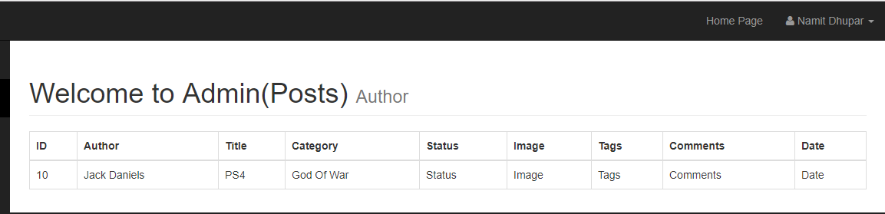

Now, in order to add the posts’s database content inside the table, the MySQL query used for the same will be: **“SELECT * FROM posts”** and hence, with the help of this, we find the following result:

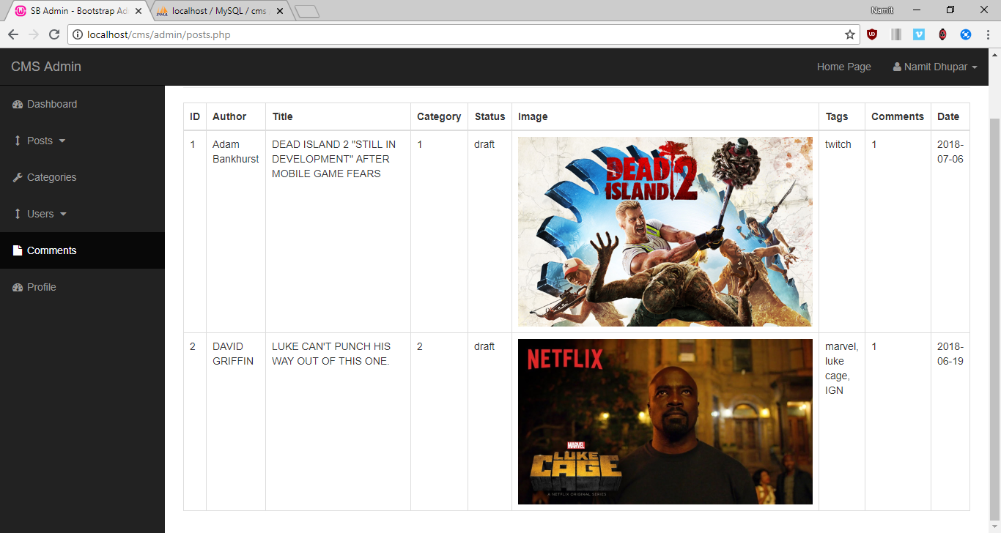

So in order to add post, We create a simple Form related to the fields we created within the database, which looks as follows:

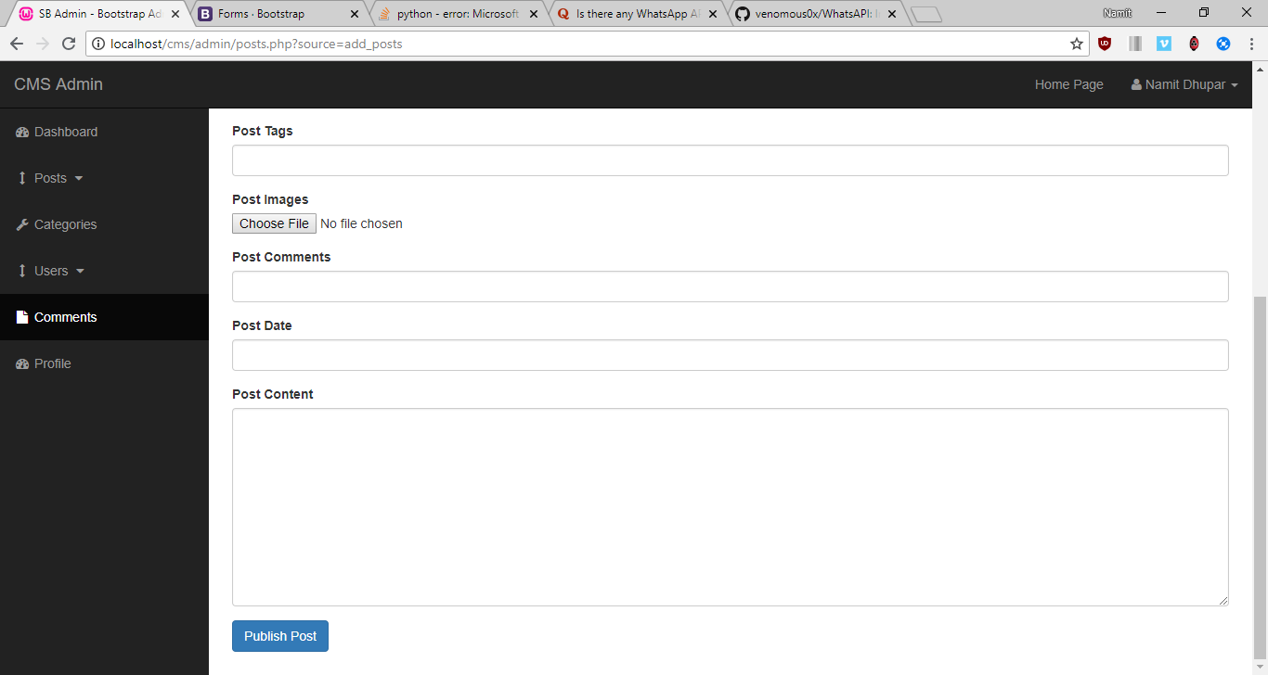

Such that an author can write his/her post and publish it within our webpage, thereby making there own entry within the database without directly interacting with it.

I would like to note another additional functionality for the choose image, where, whenever we chose an image, we must send that first to some temp location before sending that into the server, and to do that we use the super global function called, **$_FILE**

**ie** from the downloads, we are able to move this image file into the “Images” folder of our CMS project

And the PHP function responsible for this displacement of file is called: **move_uploaded_file()**

**6.3 Post Data**:

So, Now we input the information inside the following form, which we will see within the Database this time

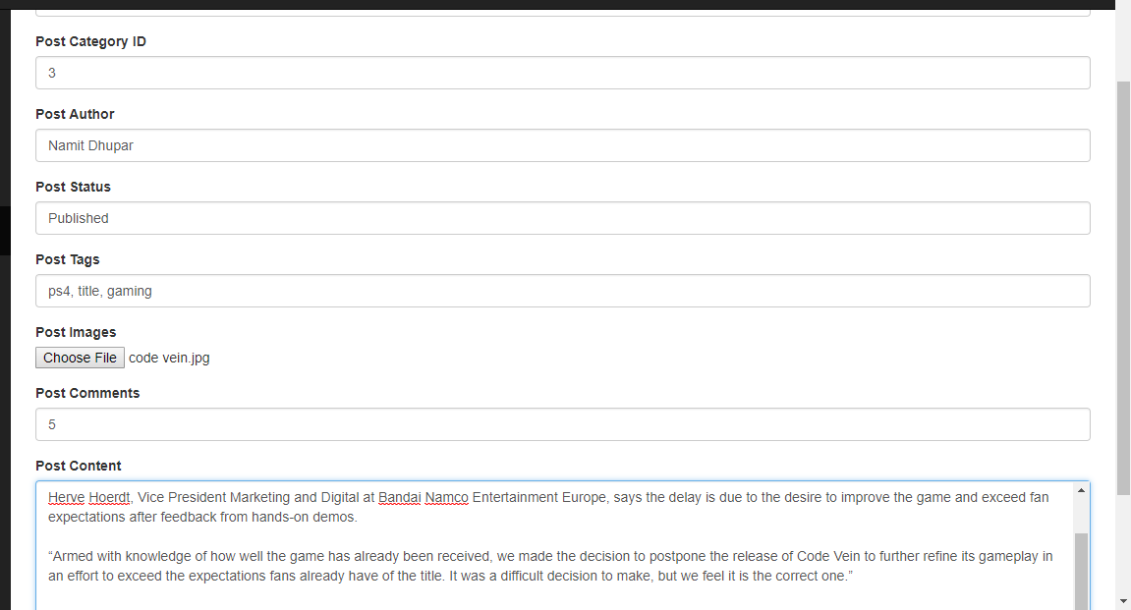

So after Pressing the publish post button, the entire data will go into the post table of the database:

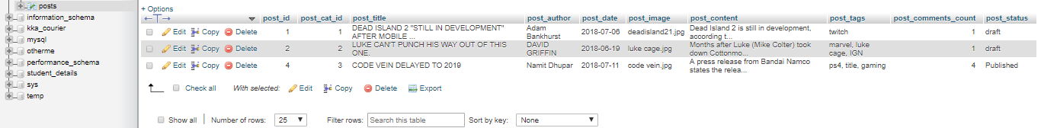

So Finally, we can see the output in the front page of our CMS Application:

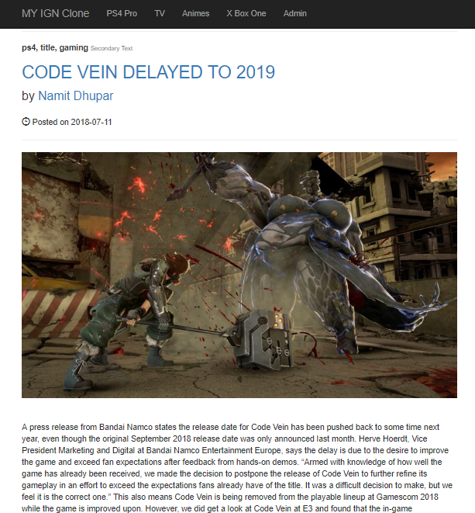

So here the MySQL query used will be: **"INSERT INTO posts (post_cat_id, post_title,post_author,post_date,post_image,post_content,post_tags,post_comments_count,post_status) VALUES('{$post_cat_id}','{$post_title}','{$post_author}',now(),'{$post_image}','{$post_content}','{$post_tags}','{$post_comments_count}','{$post_status}')";** where **now()** displays current date.

**6.4** **Delete Post ID:**

We make a separate Delete link in the post table, 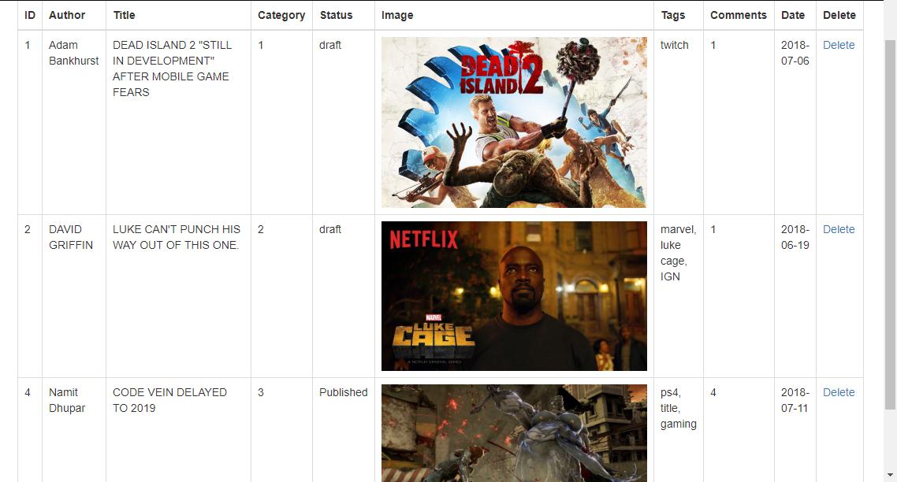

So, now if we want to delete the post with ID=4, we use the following MySQL Query: **“DELETE FROM posts WHERE post_id = $post_id”**

Hence, we obtain the following result after pressing the Delete Link, our post table will look like this:

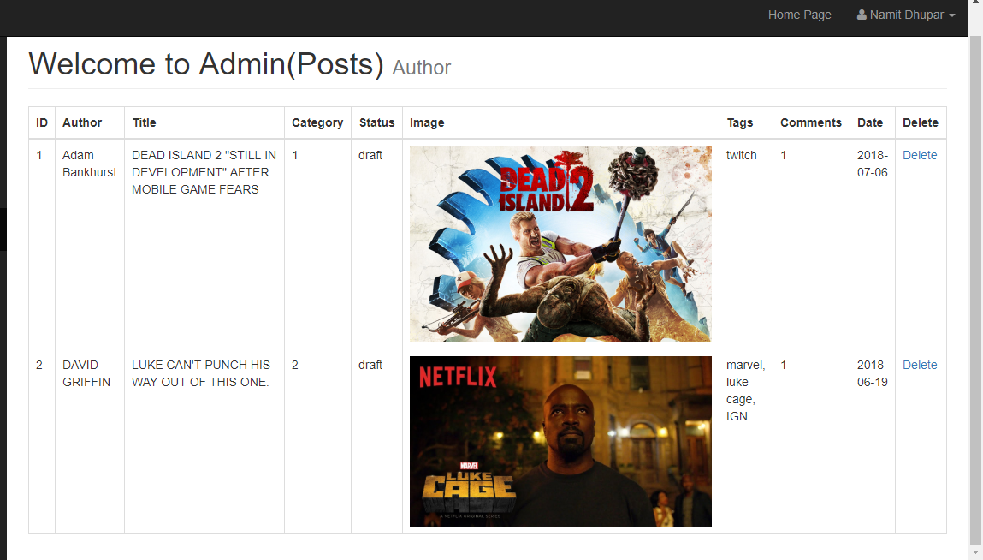

**6.5**  **Edit a post**:

Similar to Delete, we create an Edit click link inside the above table, as above:

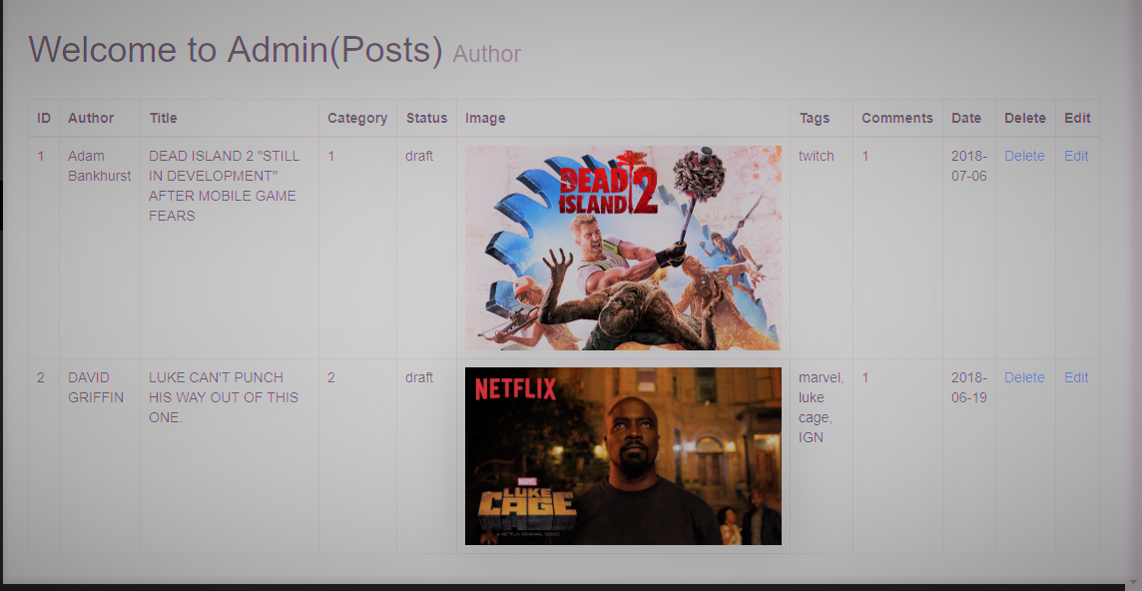

Now, We can edit the particular post, by just clicking on the edit option, and then we get redirected to a page where the particular post’s data be presented onto the Input area of the form:

Ex: on editing the First post, We see the following; ***(See the changes made in the URL)***

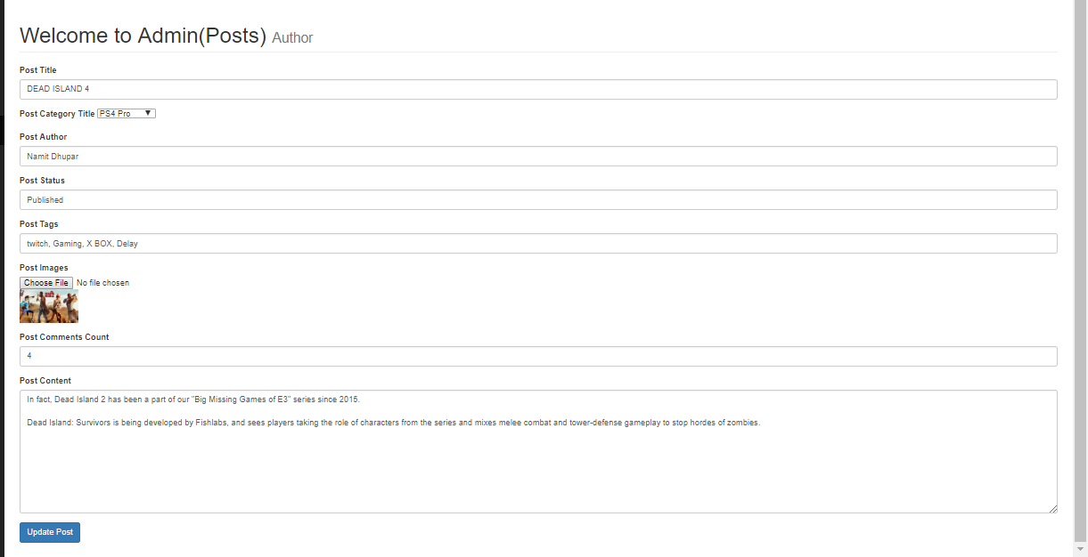

This was possible due to the following MySQL query: **“SELECT * FROM posts”** just as seen in **update_cat.**

Hence, We can finally make the changes within our same edit page, with the help of the following SQL query:

**"UPDATE posts SET post_title = '{$post_title}', post_author = '{$post_author}', post_cat_id = '{$post_cat_id}', post_status = '{$post_status}', post_image = '{$post_image}', post_tags = '{$post_tags}', post_content = '{$post_content}', post_date = now(), post_comments_count = '{$post_comments_count}' WHERE post_id = $update_post_id";**

Hence, on clicking the button called, Update the Post, we finally see changes within our Database, but when it comes to updating images, we need to find a bit different approach, which mean that we have to first check if the Image Choose file input is empty, which can be know by a PHP function called,  
**if (empty($post_image)),** and later an SQL statement of**: “SELECT * FROM posts WHERE post_id = $post_id”.**

So after all this, we are finally able to see the changes inside our Database after Pressing the **Update Post** button as follows:

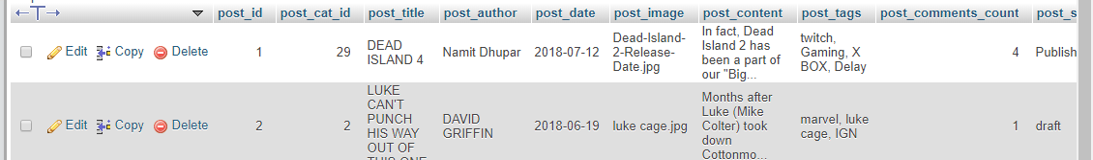

As well as in our **View post table**:

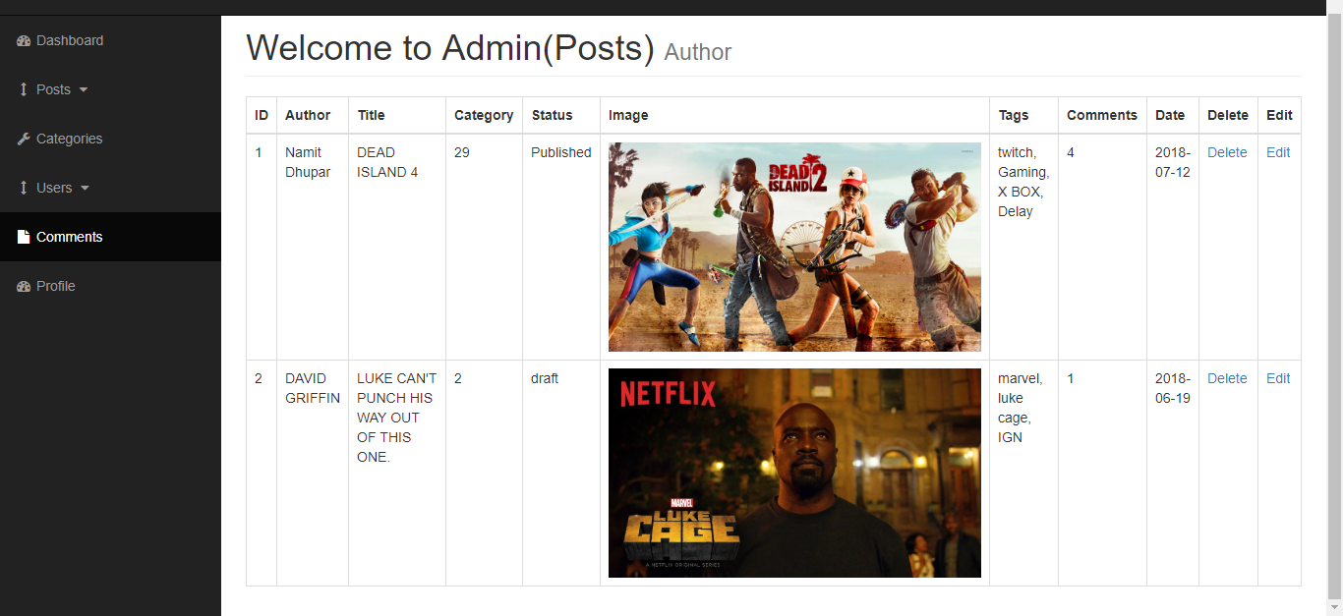

And finally, within our **Home Page also**:



**6.6 Displaying Category Title in the posts table:**

If We want to display the category title instead of the id, then we make another MySQL query: “**SELECT * FROM category WHERE cat_id = ${post_cat_id}**”. Which will present us with the following output:

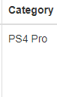

**6.7** **Displaying Category Title in the dropdown menu of the Add post page:**

In order to do this, we use the same query that is: “**SELECT * FROM categories**”, and hence we see the following result while adding a new post:

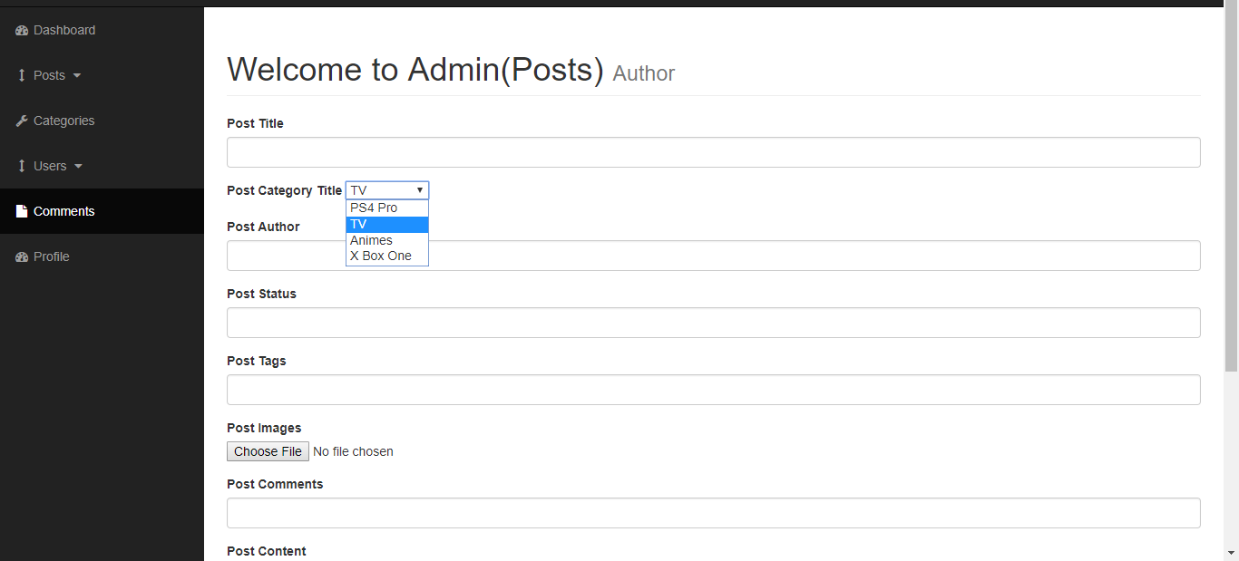

So, when we enter a new entry inside the database’s post table, we find that the finally created post displays the category title as mentioned by the Category title dropdown.

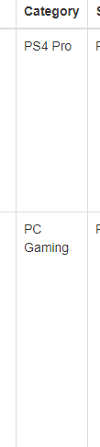

**6.8 Displaying Indivisual posts by clicking on the title:**

According to this logic, we need to click on a title and this takes us to a page with the contents associated with that particular id only,

Such that, on the index.php file, we give the following link to title such that: **post.php?p_id=<?php echo $post_id; ?>** as the link to that page, and the $post_id is used to get the post of that particular ID where we clicked, by the help of the following MySQL function: “**SELECT * FROM posts WHERE post_id = $post_id”.**

Observing the URL, we pretty much get a clear Idea that how the particular ID is displayed inside the address bar:

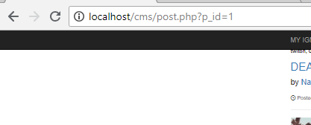

And hence, the entire page with p_id=1 will look something like this:

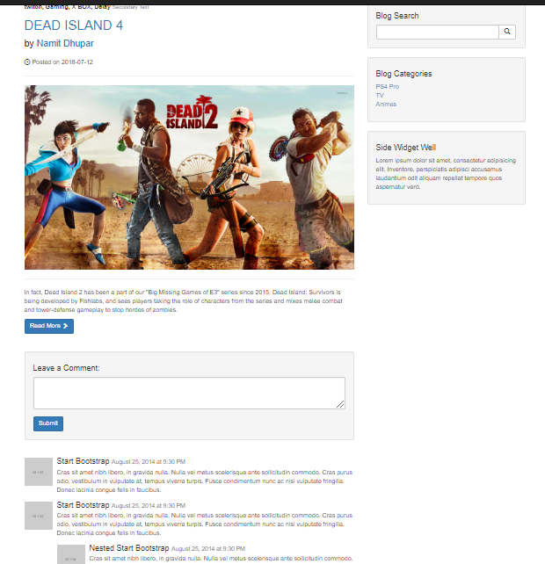

**6.9** **Adding Category to the Sidebar**: The Sidebar of the homepage consists of the categories of all my posts present within my CMS application.Such that, the webpage has the following posts belonging to it’s respective category, 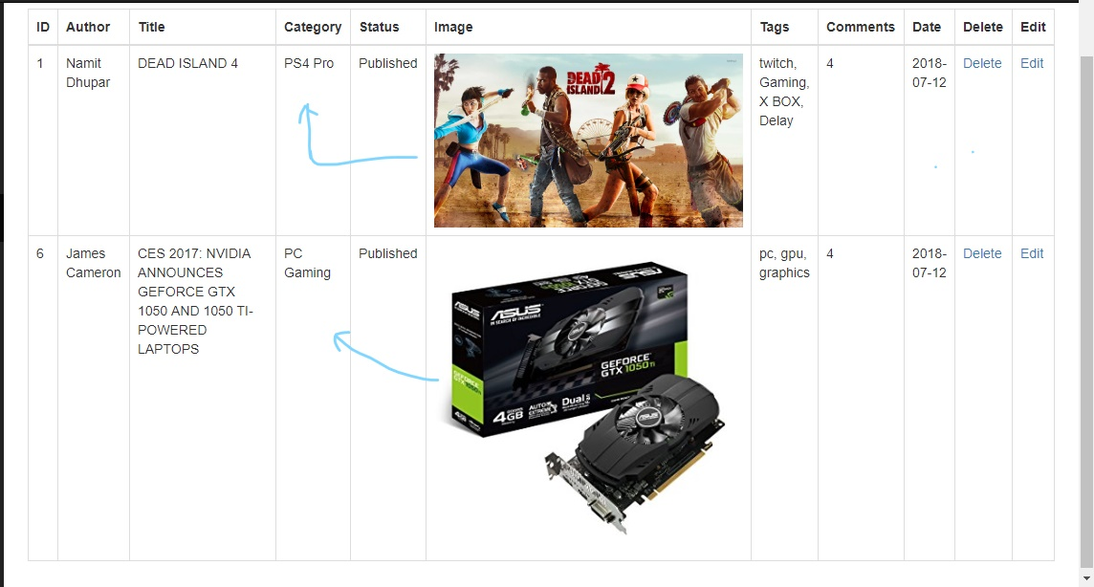

Now On clicking on the Sidebar of the home page, we want to display the post, belonging to that very category only, so this was done by passing a URL in the sidebar’s file ie “ **category.php?category=$cat_id”** and this was made possible by the MySQL function: “**SELECT * FROM posts WHERE post_cat_id = $post_cat_id”.** Like if we click on the PC gaming category on the above sidebar link, we are sent to the above URL and Page:

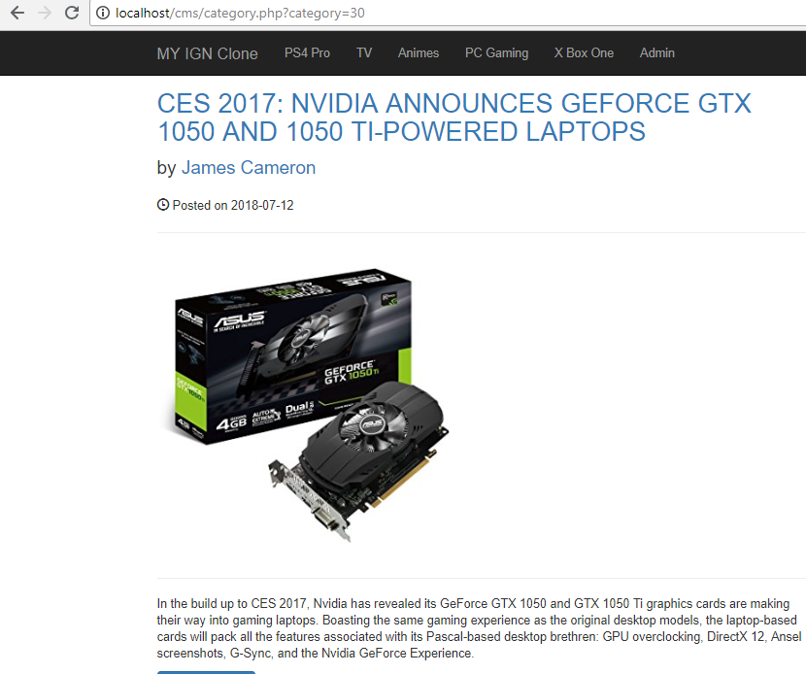

**CHAPTER 7**

**ADDING COMMENTS**

**7.1 Create Comment table:**

inside the CMS database, we create another table, called the comment table, and this table’s structure is as follows:

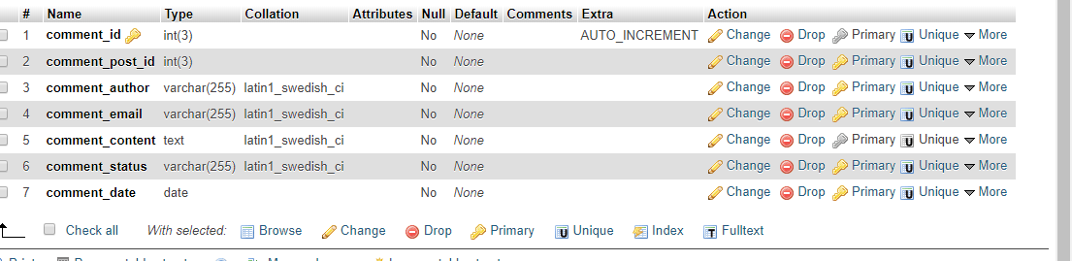

And after inserting some data, our table looks something like this:

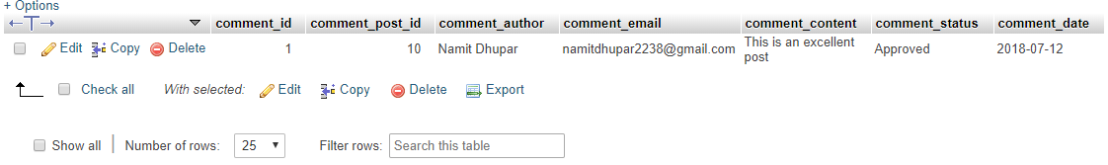

**7.2**  **Displaying the comments in the Webpage:**

We have the following data, which we want to present within our webpage, for this we got to our Admin Page and on it’s side Navbar we see an option called, Comment:

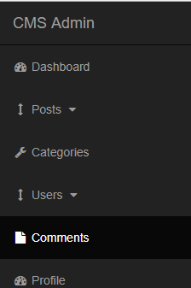

**7.3** **Displaying Comments in the Table:**

For this, we simply make a form related to the database’s comments table column and with the help of the MySQL function**: “SELECT * FROM comments”** we fetch the data from the column of the database and add it to our table:

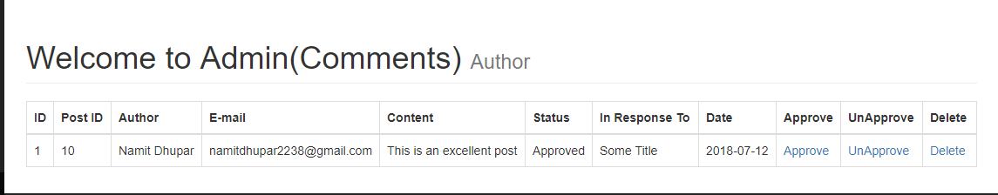

**7.4 Storing comments from Post in frontend to Database:**

Construct a Form for the user to enter their comments inside the website:

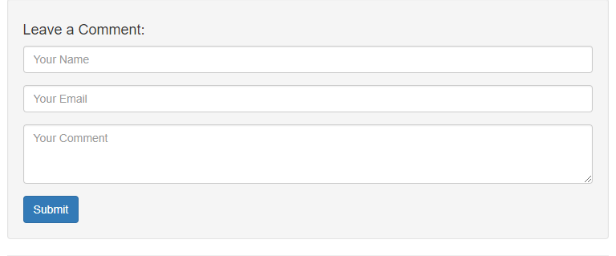

Now, we use the superglobal method **for $_GET[‘p_id’];** as well as the MySQL Query**:” INSERT INTO comments (comment_post_id, comment_author ,comment_email ,comment_content, comment_status, comment_date) VALUES($the_post_id, '{$comment_author}', '{$comment_email}', '{$comment_content}', 'unapproved', now())";**

Which will insert all the data from the Form into our database, We fill the details and enter the submit Button.

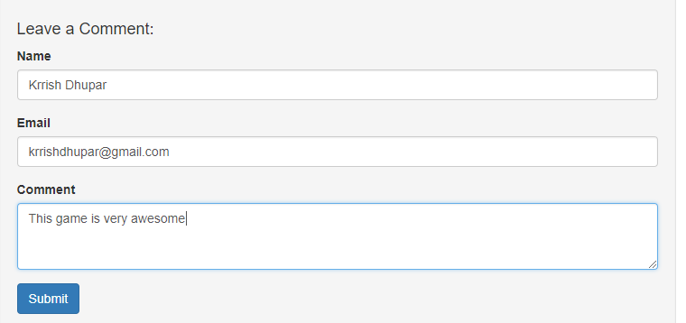

After Entering the submit button, We can see the table is created inside our database:

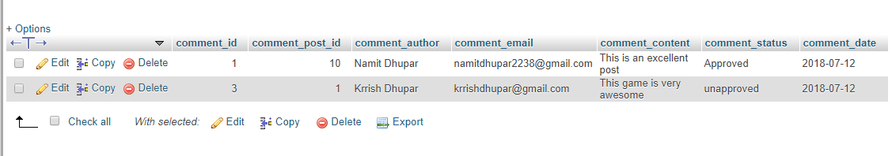

And the Comment Table in the Admin page as well:

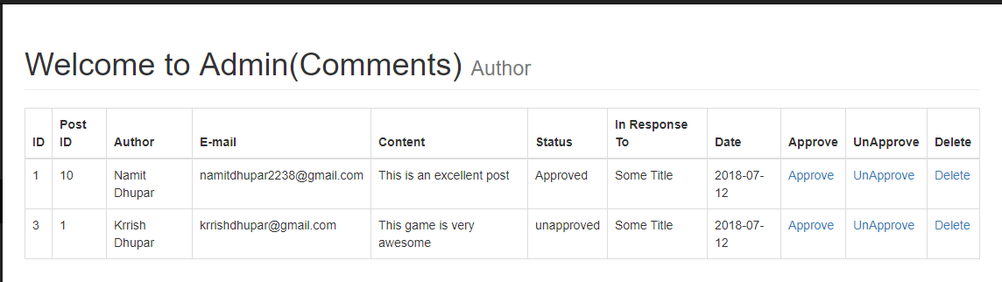

**7.5** **Dynamic Responder:**

Even though our table has all the dynamic values, but there still is a column called “In Response To” which carries on with a static value, even though we need to display the information that comment has been made about which title of the post in our website.

So with the help of the MySQL Query: **“SELECT * FROM posts WHERE post_id = $comment_post_id”,** we need to interact with the posts table in the database and by passing the URL referencing the post table, ie: **posts.php?p_id=$post_id**, We can determine the Title related to the Comment:

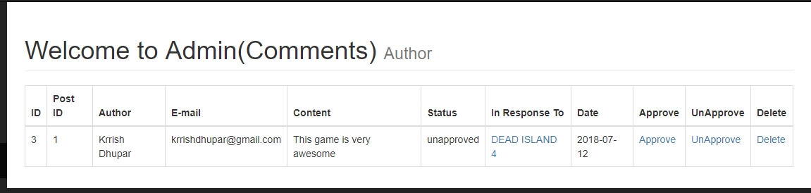

**7.6** **Deleting the comment:**

We need to delete undesirable comments, So in order to do that, we use the following MySQL query: **“ DELETE FROM comments WHERE comment_id = $del_comment_id**”.

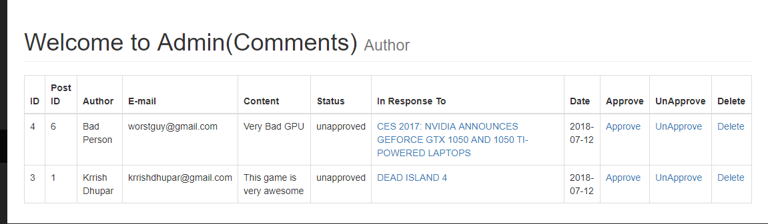

So, for example, If we want to remove the comment of the Bad Guy, then we simple click on the delete button and this would simply remove the person’s from the database.

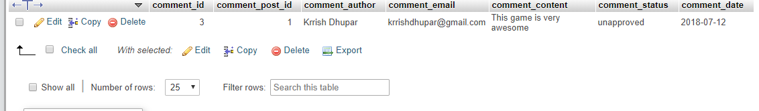

Hence we see, that the comment is no longer available inside the database.

**7.7 Approving and Unapproving comments:**

This one is very much similar to Deleting a comment from the database table, MySQL function:

**i.) *Unapprove* = “UPDATE comments SET comment_status = ‘unapprove’ WHERE $comment_id = $unapprove_comment_id”.**

**ii.) *Approve* = “UPDATE comments SET comment_status = ‘approve’ WHERE $comment_id = $approve_comment_id”.**

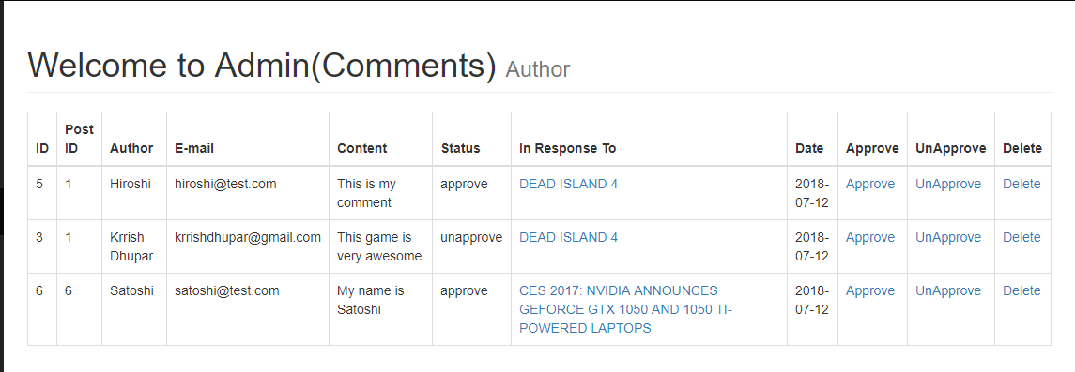

**7.8 Displaying the approved comments only in the front page:**

For this we use a MySQL function called **"SELECT * FROM comments WHERE comment_post_id = $my_post_id AND comment_status = 'approved' ORDER BY comment_id DESC";**   
Here the last four query words means that here we show by the Newest comment first. Hence we see this following output:

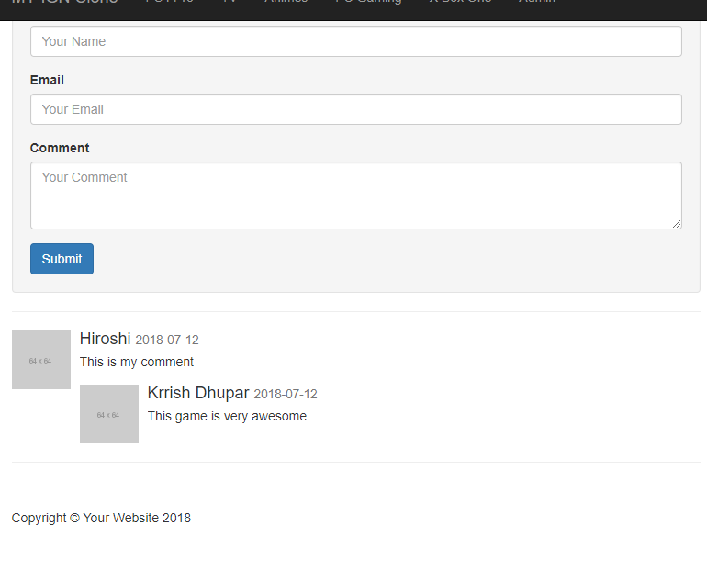

**7.9** **Making the Comment Count in the posts.php Dynamic:**

The MySQL Query used here is **“UPDATE posts SET post_comments_count = post_comments_count + 1 WHERE post_id = $the_post_id"**

Such that the when we make a comment inside any given post, the post_comments_count column within the posts table will increment by 1 each time a comment gets submitted.

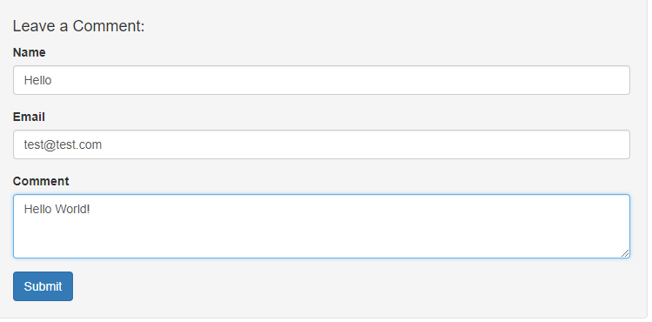

So after clicking on the submit button, we have to note that post_comments_count was earlier static and was set to 4 by default, hence by now making it dynamic and incrementing this by 1, we must see that the post_comments_count should be 5 now, which is true.

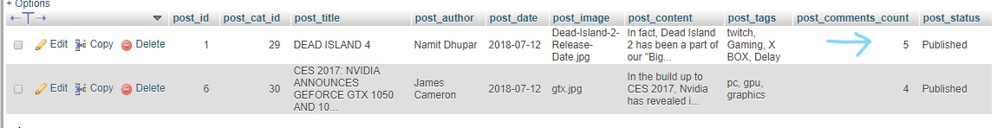

**CHAPTER 8**

**ADDING USERS**

**8.1 Create A user’s table in CMS database:**

Along with Posts, Categories and comments table, we need another kind of table, also known as the user’s table.  
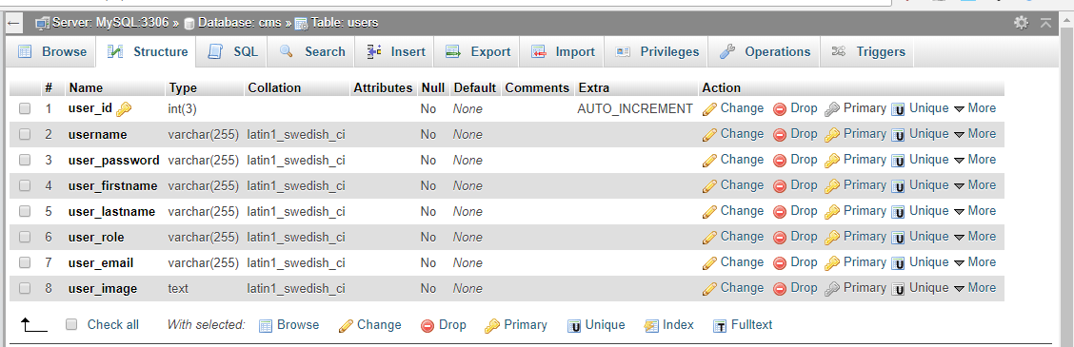

So, we insert random data within the table, which means that:  
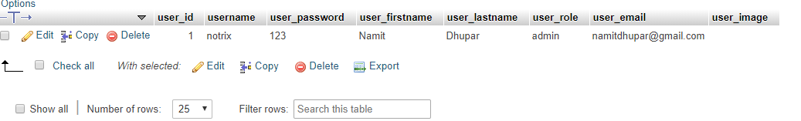

**8.2**  **Displaying the users table in the Admin page:**

This is possible with the MySQL function: **“SELECT * FROM users”,** hence we see the following output:

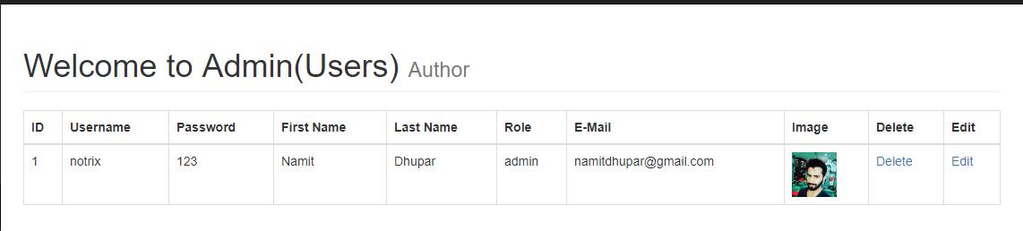

**8.3 Adding users to the database from the Admin page:**

In the User’s dropdown, we see two categories:

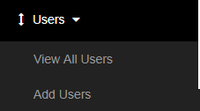

On the View All Users, we see the above table which contains all the user’s information and similar to post dropdown, in the Add Users, we see the following Form:  
 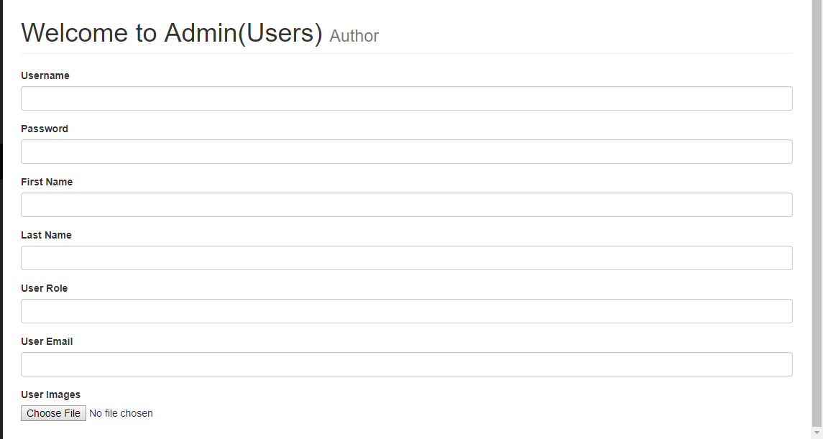

Let’s enter some credentials inside the above forms as follows:  
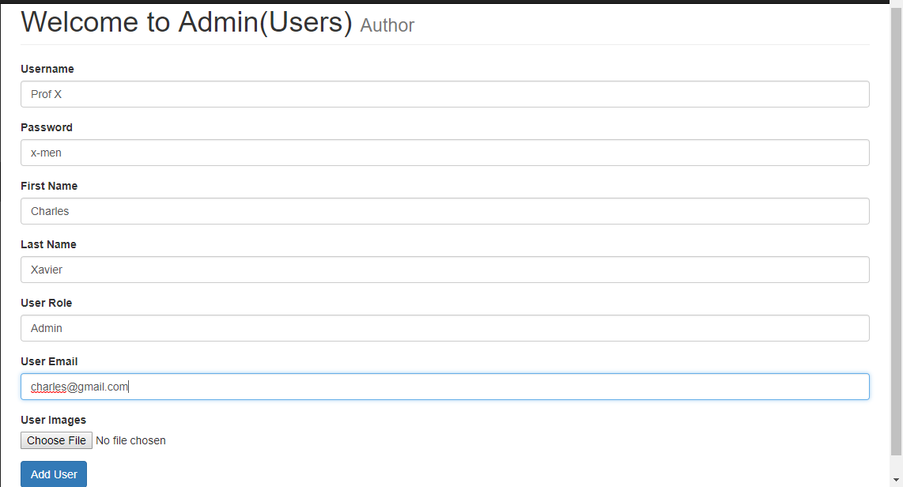

Hence, with the help of the following MySQL Query**: "INSERT INTO users (username, user_password,user_firstname,user_lastname,user_image,user_role,user_email) VALUES('{$username}', '{$user_password}', '{$user_firstname}', '{$user_lastname}', '{$user_image}', '{$user_role}', '{$user_email}')";**

The content is finally inserted into the database and hence the following row is added into the View All User’s column:  
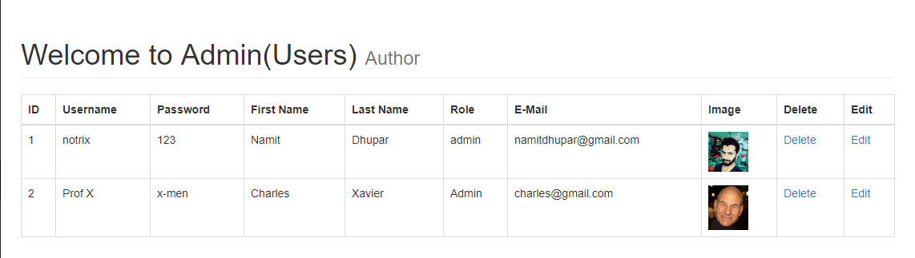

As well as, inside the database:  
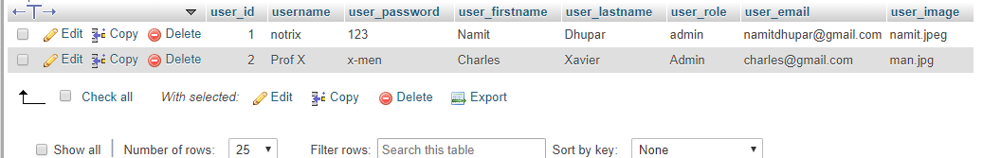

**8.4** **Deleting User’s from the table:**

Consider the following User’s table, with the following entities:  
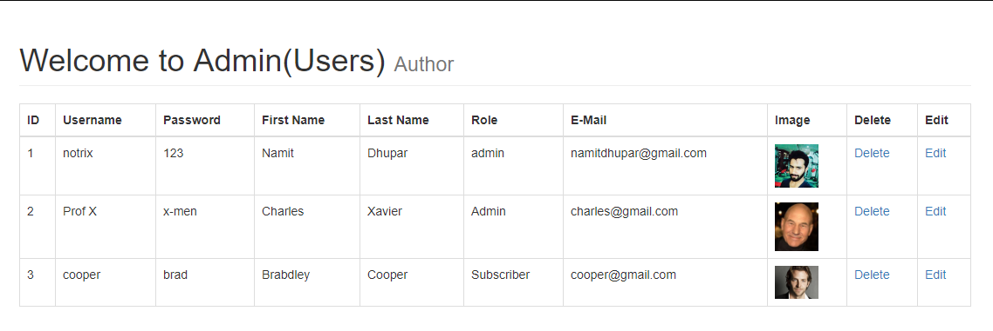

And say, we want to delete **the third user** from the table, So for this we would use the following MySQL Query**: "DELETE FROM users WHERE user_id = {$del_user_id} ";**

Hence we obtain the following output in the user’s table:  


**8.5 Editing the user’s ID**:

The MySQL query "**SELECT * FROM users WHERE user_id = $update_user_id";**So when we press the Edit Button, the information is appended inside the table as follows:  
 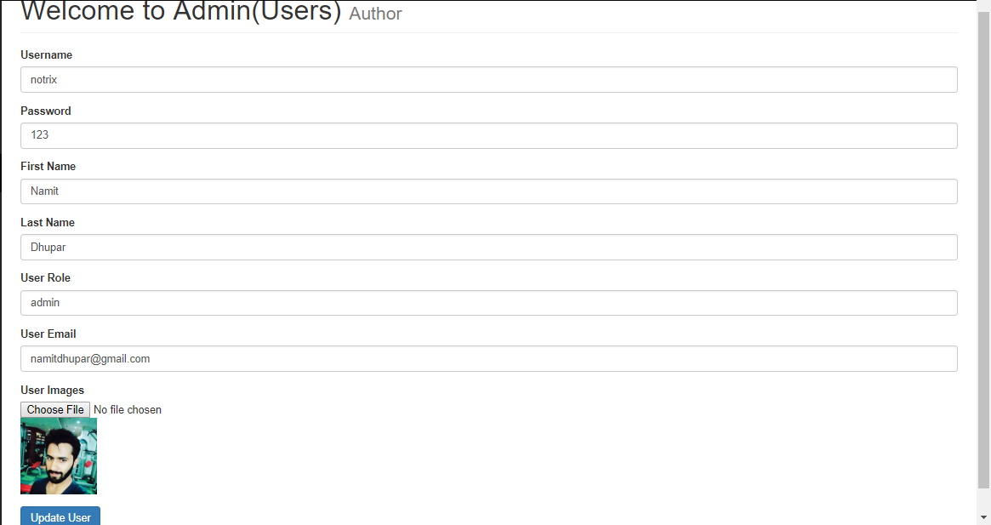

**8.6** **Updating the User:** The MySQL query: **"UPDATE users SET username = '{$username}', user_password = '{$user_password}', user_firstname = '{$user_firstname}', user_lastname = '{$user_lastname}', user_image = '{$user_image}', user_role = '{$user_role}', user_email = '{$user_email}' WHERE user_id = $update_user_id".**

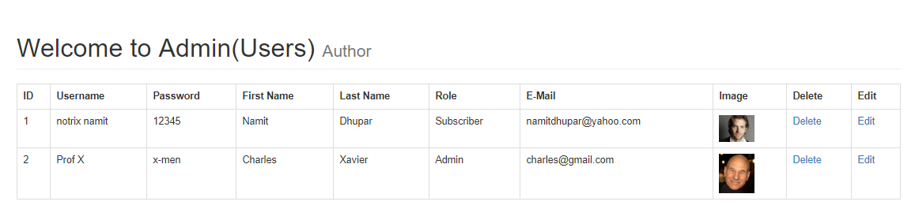  
And the Database will also the shows the updated value:  
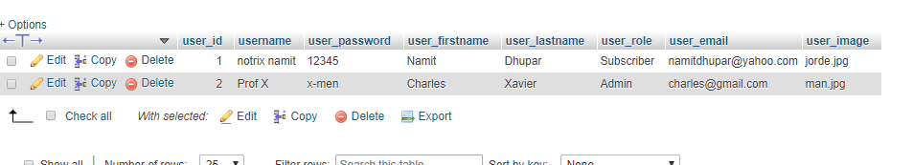

**CHAPTER 9**

**ADDING LOGIN FUNCTIONALITY**

**9.1 Creating a Login Form:**

Within our webpage, we make a Login Form, which looks something like this:  
 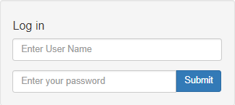

This form is located at the same location as that of the Sidebar.

**9.2** **Adding a Login Page:**

After creating the above form, we defined the form’s action to be sent to to the login.php and later the data entered inside the form fields can be verified by the help of a MySQL Query which says: **“SELECT * FROM users WHERE username = $username”;**

**9.3 Validation:**

If the entered username and password entered in the form do not match with the username and password present in the database then we should be redirected to the index page

**if($username !== $db_username && $password !== $db_user_password )**Example, we have the following entities in the users table:



And if we try to enter any other person with a mismatching username or password with the persons inside of our database, the following would happen:  
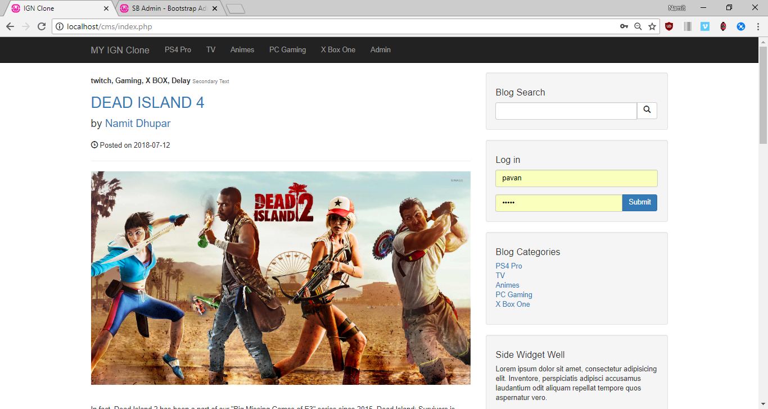

We, see that we get redirected to the index page. Otherwise on filling the correct details, it takes us to login.php.  
However, if we enter a valid credentials, we will be taken straight to Admin Page: and the function used here will be**: if($username == $db_username && $password == $db_password ){**

**header("Location: ../admin"); }**

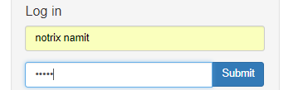

Therefore, entering this would lead us straight to the Admin Page:  
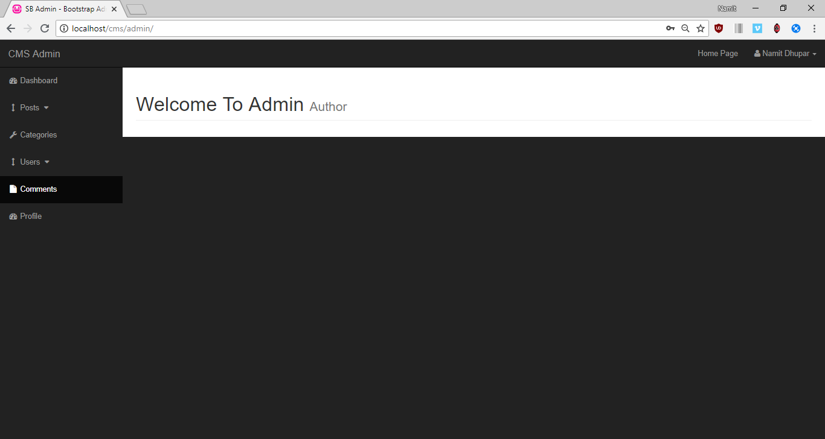

**9.4 Displaying username inside of the admin page:**

In order to do this, we require to create a session, which is done by the PHP function: **<?php session_start() ?>** inside both login page as well as Index page of the admin folder and the super global variables called **$_SESSION**

Therefore, once we enter the following credentials into the login page:  
 

We are sent to the following in the admin Panel:  
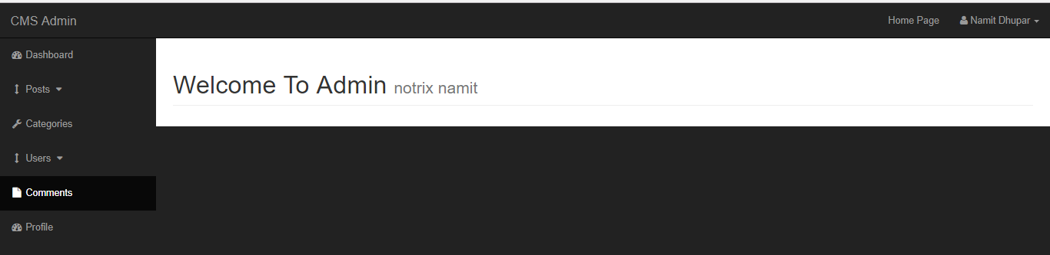

`Where we can clearly see the username of the one of the users present within the database.

**9.5 Giving right access to the right user:**

this can be achieved by a single PHP logic: **if($_SESSION[‘user_role’] !==admin**

such that in the following user’s table we observe that the following user’s role is *either of Subscriber or of Admin*

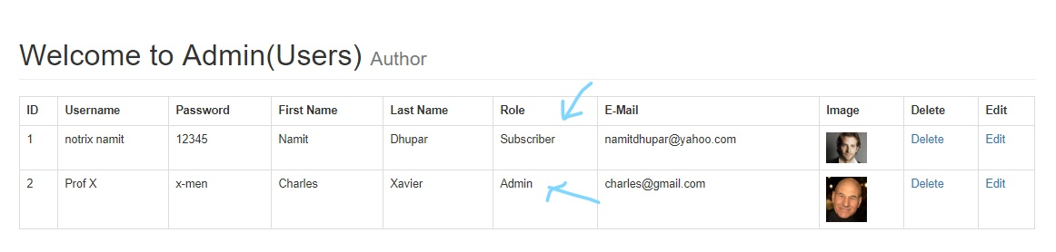  
hence in the case of subscriber(Notrix Namit), we have to remain inside the index page:  
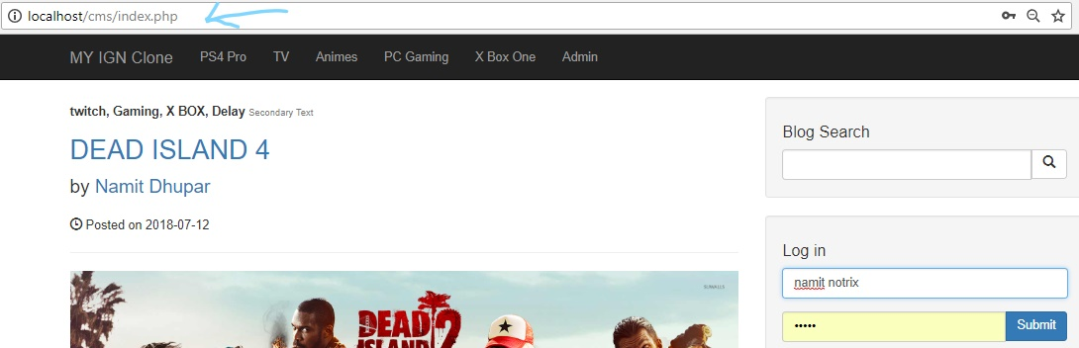

But in case of admin(Prof X), we should be redirected to the admin page with the username of the admin present as the secondary text:

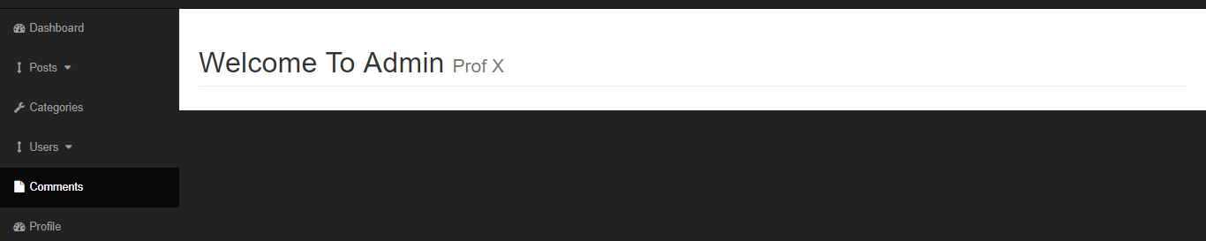

**9.6 Logout Page:**

If the current user wants to logout from their page, it can be simply done by the clicking on the Logout link.  
 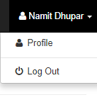

So, for this we simply we create another page inside our root folder called “logout.php” and here we simply Nullify all the Sessions, by simple**: $_SESSIONS[‘username’] = null**.  
And later after clicking on the logout page, we are sent to the Index.php page:  
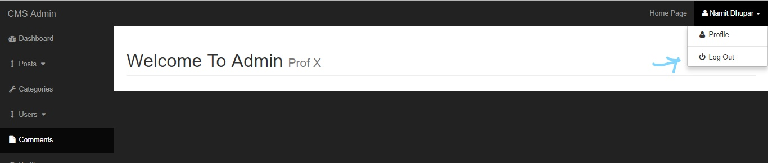

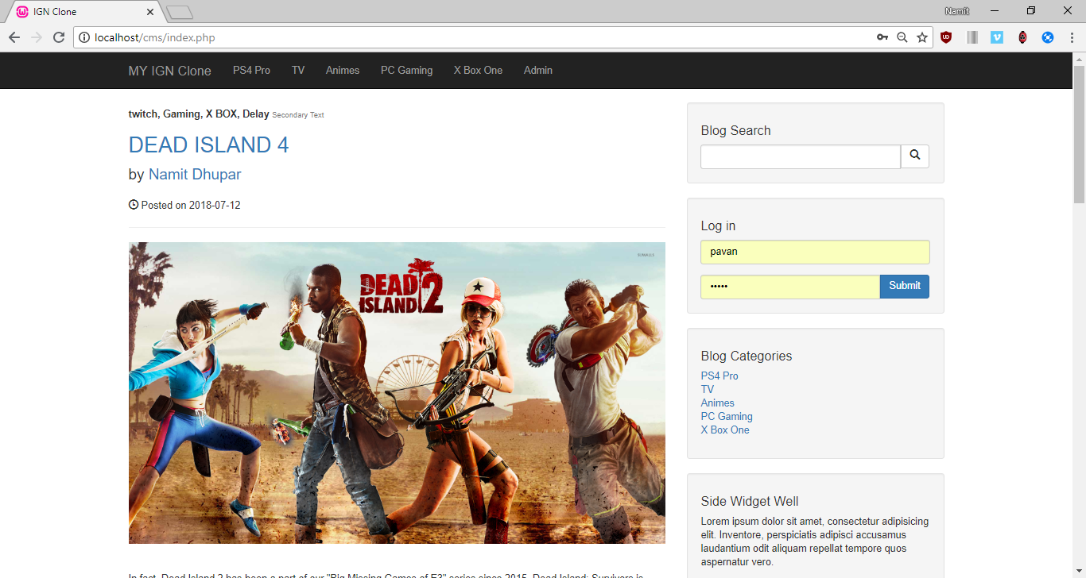  
And also, the user would be unable to access the admin, one logged out.

**9.7 Displaying Profiles of the users:**



We want to display all of the information related to the user which is currently logged into our website.  
In order to do this, let’s add more users into our databases:

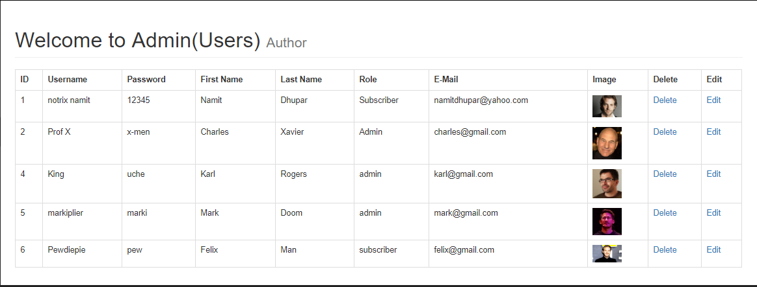

So, the setup is very similar to that of the Add Users’s form and also instead of using a GET request from the the database, we simply look for the sessions belonging to the username currently logged into the website.

And this would be very similar to edit user’s as demonstrated before.

**CHAPTER 10**

**DASHBOARD & REGISTRATION**

**10.1 Adding Widgets:**

The widgets are the important component of every Admin Dashboard page and looks as the following:  
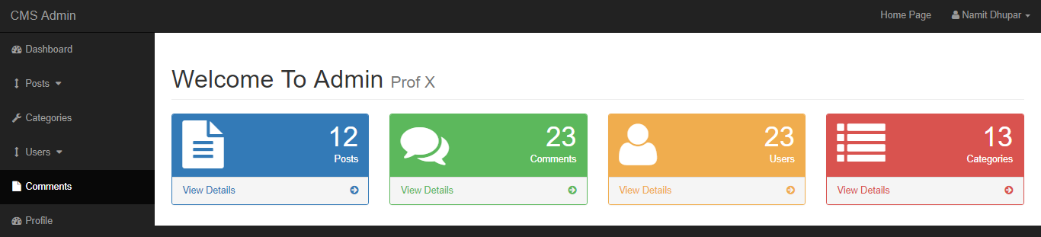

**10.2 Making those widgets dynamic:**

**i.)No. Of Posts:** For this, we use a simple MySQL Query: **“SELECT * FROM posts”;** and then count the number of rows in using the PHP function: **mysqli_num_rows()**

As we see that the total number of rows in the View Posts folder:  
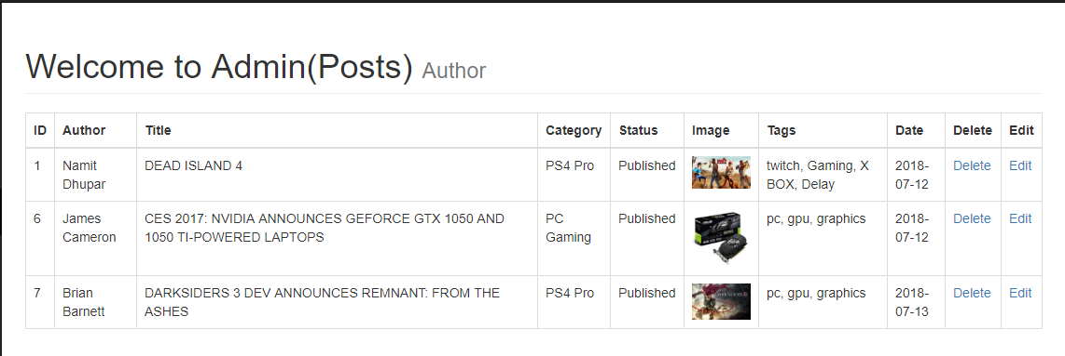

So, for the dynamic post widget, it must show the Number of Posts = 3:  
 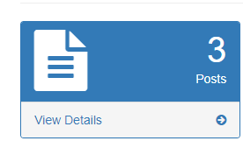

**ii.) No. of Comments:** Similarly, for the comment counts, we run a MySQL Query: **“SELECT * FROM posts WHERE post_comment_count = $post_comment_count” OR “ SELECT * FROM comments”**

Here, again in the comments table, we see 3 rows:  
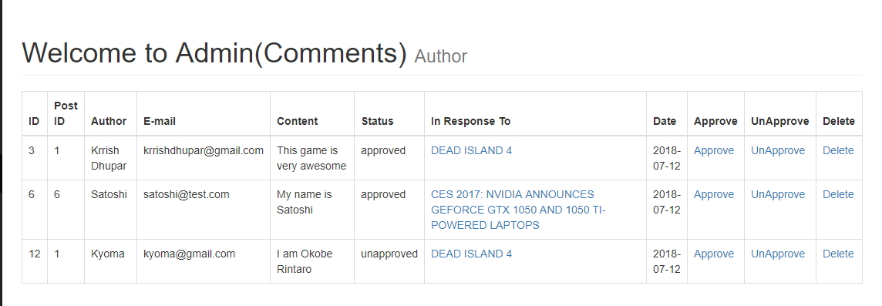Therefore, the dashboard must display 3 comments:



**iii.)Number of users:** For this the MySQL query **is “SELECT * FROM users”.**As we see that the number of rows in the users table are:

And similar php function of **mysqli_num_rows()** is used here



Hence we see that there are 5 rows in total, so this is the output:  
  
 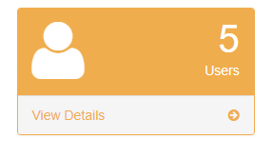

**iv.) No of Categories:** For this we use the MySQL Query **“SELECT * FROM categories**”  
 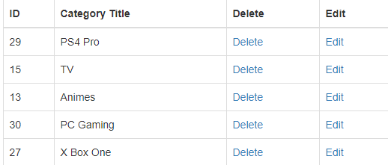

Also the number of rows, here are 5, hence we see that in Dashboard:

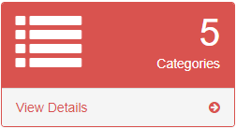

**10.3 Adding Charts into the dashboard:**

For this we use, **the google charts API(https://google-developers.appspot.com/chart)**And the Bar graph shall be used here:  
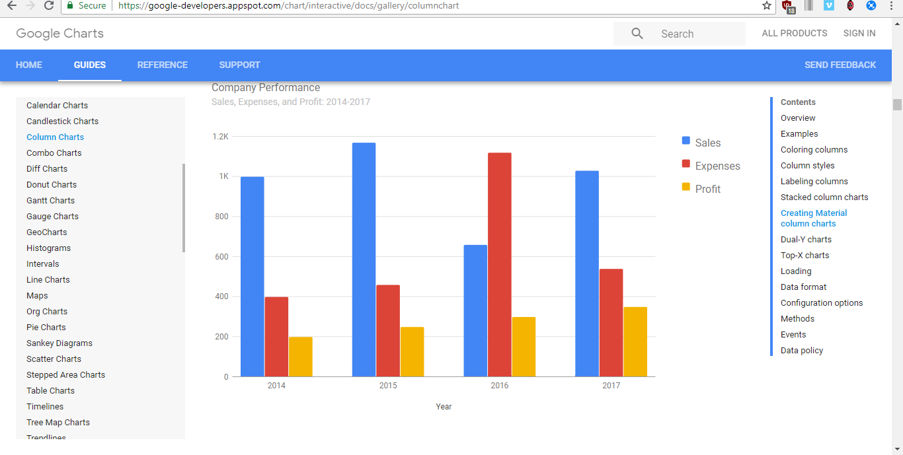And the API can be fetched by including the following link inside our admin-header.php file:  
<script type="text/javascript" src="https://www.gstatic.com/charts/loader.js"></script>

Hence, we see the following changes within our Dashboard:

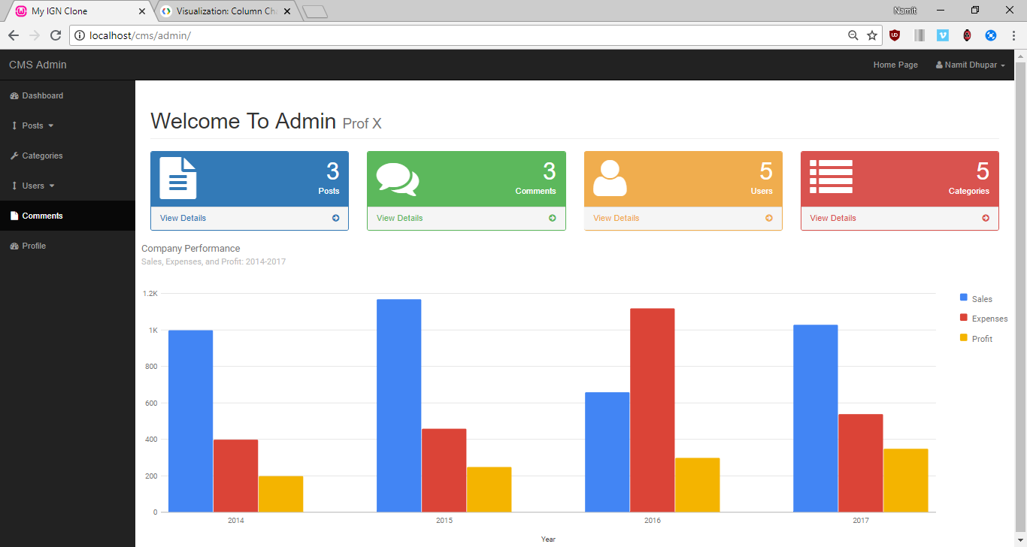

**10.4 Making the charts dynamic:**

For this we create 2 arrays, where the first array will hold information about the static headers and the second one would express the entity countings dynamically, with the help of charts.  
We run a loop 4 times as there are 4 items we need to define inside the bar graph:  
hence the actual PHP echo will be: **echo "['{$element_text[$i]}'" . "," . "{$element_count[$i]}],";**

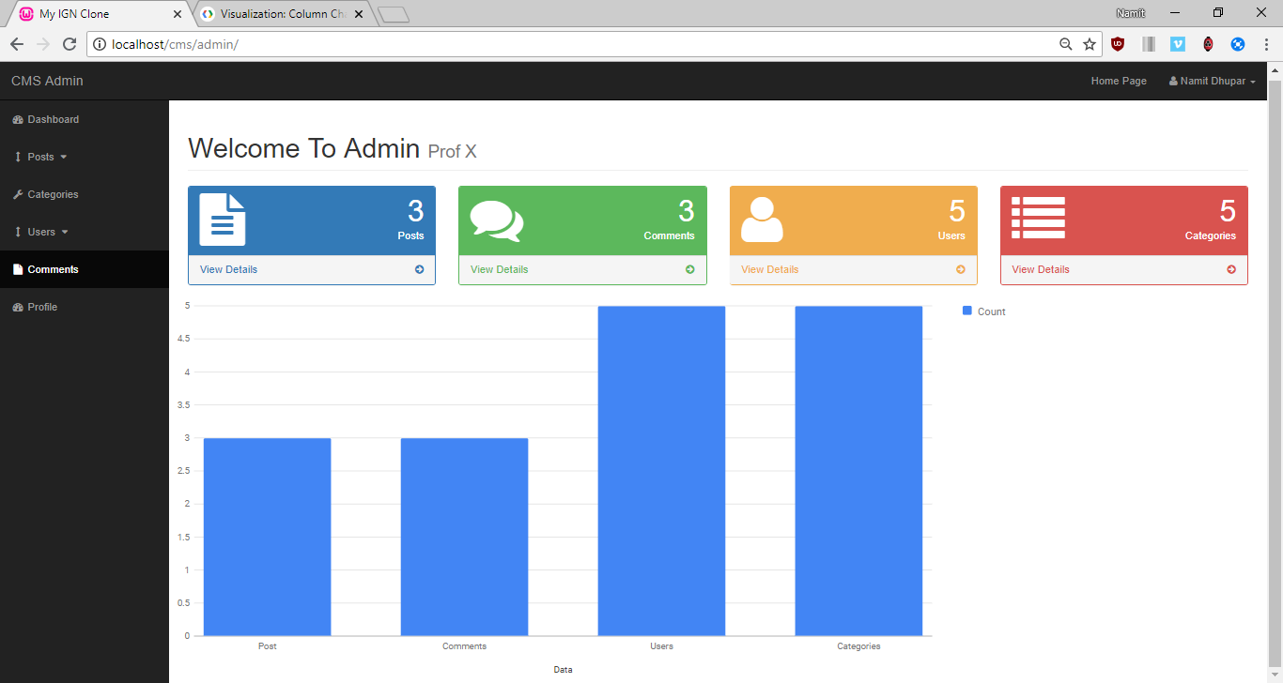

**10.5 Adding a Registration form:**

Inside the Root directory page we make a separate Registration.php page which contains the following form, where we want to allow people to register for our website.

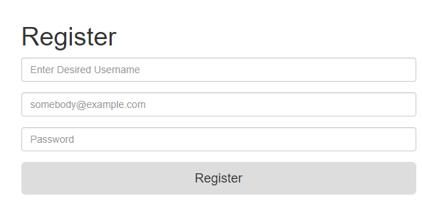

NOTE: Please use the function, **mysqli_real_escape_string();** to make the forms more secure

**10.6 Encrypting Password**:

here we will use the randSalt column present in the user’s table of our CMS database.

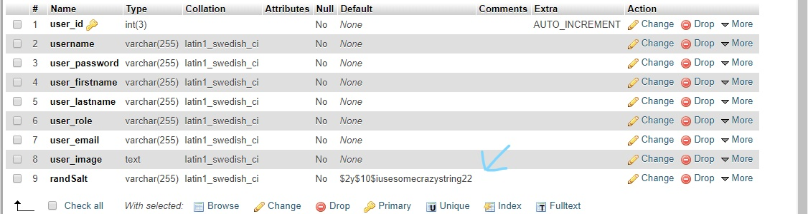

We must ensure that the randSalt column should always have the **code “$2y$10$” followed by any 22 character string.**

The MySQL Query used here will be: **“SELECT randSalt FROM users”.**

So, as we add newer users into our websites, we see that the randSalt for each one of them created shall be same:  
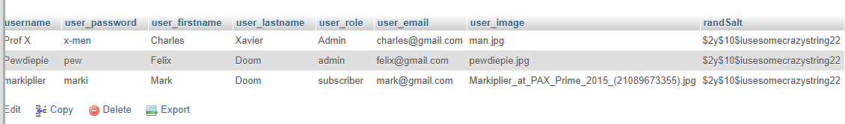

**10.7 Sending information to database:**

Now the MySQL Query for the same will be: **"INSERT INTO users (username, user_email, user_password, user_role) VALUES('{$username}', '{$email}', '{$password}', 'subscriber')";**

And also, this query would only be followed, if and only if the fields in the registeration form are NOT EMPTY.

**REFRENCES & BIBLIOGRAPHY**

* <https://www.udemy.com/php-for-complete-beginners-includes-msql-object-oriented/>
* <http://php.net/docs.php>
* <https://dev.mysql.com/doc/>
* <https://getbootstrap.com/docs/3.3/getting-started/>
* Learn PHP & MySQL by Edwin Diaz
* The Joy of PHP Programming: A Beginner’s Guide – by Alan Forbes

## 